**PARENT’S EVENING**

Its Parent’s Evening next week.

**Monday 12TH February 2018: 3:30 – 5:30pm &**

**Thursday 15th February 2018: 5:30 – 7:30pm**

You should now have your appointment time to see your child’s/children’s teacher on Parent Evening. If you have not returned your Parent’s Evening slip for an appointment to see your child’s class teacher please call into the school office or speak to your class teacher on the playground as soon as possible.

**UDATED PHONE NUMBERS**

We frequently send out information to you via our text service. Please ensure that you inform the Office of any changes to your telephone numbers so that if we can ensure you receive the messages.

**COLLECTING FROM SCHOOL**

We’d really appreciate Parents and Carers supporting us with an ongoing issue regarding adults who collect children. At the beginning of the school year we asked all parents and carers to provide us with the names and contact details of adults who will be collecting your children. On a number of occasions recently we have had adults come to collect children that we are unaware of. We will not, under any circumstances, allow children to leave with an unknown adult, however we are then being criticised and on occasions verbally abused for not allowing children to leave. This is totally unacceptable and it is the responsibility of all parents and carers to inform us who can collect their children. ***If someone other than yourself should come to school to collect your child at the end of the day, please inform the class teacher or the office who will be collecting them.***

**SINGFEST TICKETS**

**Singfest – Broadway to Motown** with the Love Music Trust.

Years 4, 5 and 6 will be joining with other schools to sing in a massed celebration concert at Crewe Lyceum on Thursday 29th March at 10am. Tickets are available for parents and relatives buy and attend the concert.

Tickets are available online at the following website: [www.lovemusictrust.com/schools/singfest-broadway-to-motown/singfesttickets](http://www.lovemusictrust.com/schools/singfest-broadway-to-motown/singfesttickets)

Please be aware that when booking tickets Marlfields are singing in concert **number 5.**

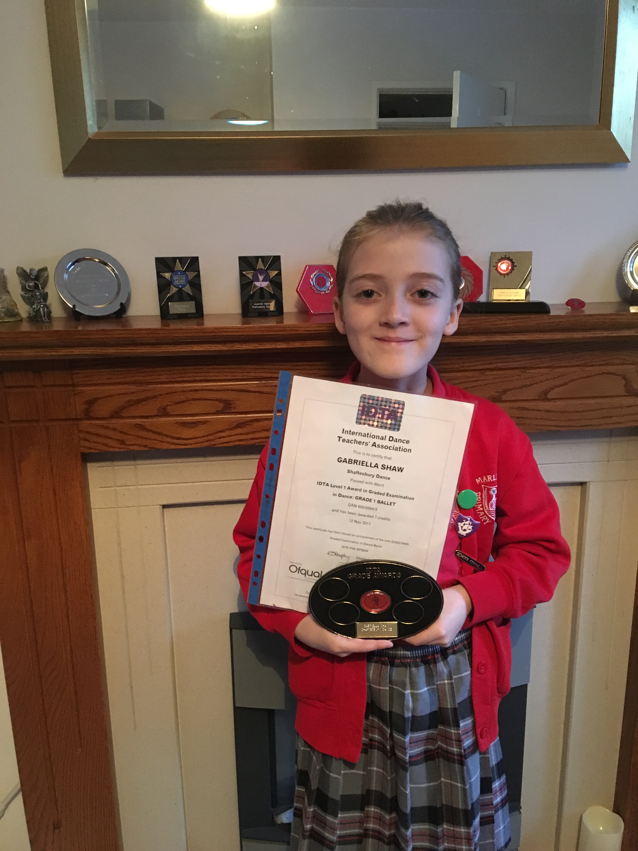**CONGRATULATIONS**

Well done to Gabriella Shaw in Class 4 on passing her Grade 1 Ballet examination.

**ATTENDANCE**

Attendance figures for last week are:

|  |  |
| --- | --- |
| **Year 1** | **99.6%** |
| Year 6 | 98.5% |
| Year 3 | 97.8% |
| Year 2a | 97.6% |
| Reception | 96.5% |
| Year 5 | 94.3% |
| Year 2b | 91.9% |
| Year 4 | 91.6% |

**Well done to Year 1 who were our winners for last week with 99.6%.**

So far this week attendance in Reception and Year 3 is at 100%

*Will Reception or Year 3 make it to the end of the week with 100%?*

*Who will the winners be next week?*

*Watch this space ……….*

**HARRY POTTER DAY – TOMORROW**

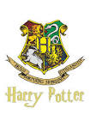The children can come into school on that day dressed as a character from Harry Potter for £1.

There will be exciting activities available during the day, including a photo booth, games and competitions for 20p and a magical potion (drink) & biscuit to buy for £1.

**HALF TERM**

We break for half term next FRIDAY on the 16th February – hasn’t it come round quickly.

We return to school on MONDAY 26th February.

Have a lovely break, keep safe and warm in the cold icy weather, let’s hope for snow and most importantly ……………………. **ENJOY YOURSELVES!**

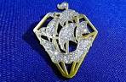**BLUE PETER DIAMOND BADGE**

Blue Peter have launched a limited edition Diamond Badge to celebrate their 60th birthday and 5000th episode. Once a child has gained a Blue Peter badge they are eligible to apply for a Diamond Badge.

All the children, age 6 years and above, have been challenged this school year to gain a Blue Peter badge through a variety of ways. To date this is the tally for the classes so you can see who is currently in the lead.

|  |  |  |  |  |  |  |
| --- | --- | --- | --- | --- | --- | --- |
| **Class** | **Y1** | **Y2** | **Y3** | **Y4** | **Y5** | **Y6** |
| **No of children who have got one** | 1 | 1 | 1 | 16 | 3 | 3 |

For ways to gain a Blue Peter badge see the website

<https://www.bbc.co.uk/cbbc/findoutmore/apply-for-a-blue-peter-badge>