ROYAL VISIT IN CONGLETON
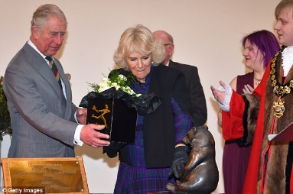
Last Wednesday, Prince Charles and his wife, the Duchess of Cornwall visited Congleton. Children were authorised to be collected early from school to go down to witness the royal visit. Two of our children, along with Mrs Isherwood were lucky enough to be invited to meet the Prince and Duchess in the Town Hall. Please enjoy the report by Evie Morgan and Sam Barnes.

On Wednesday we were unexpectedly invited to visit the Town Hall and meet the Prince of Wales and the Duchess of Cornwall when they visited Congleton. Their Royal Highnesses first went to the Old Saw Mill and then to see the statue of the dog Treo. They came to the Town Hall but they were delayed as they went into the pub called the Prince of Wales and got a free drink.
When they did arrive Prince Charles and the Duchess came and met local businesses and charities, as well as a few lucky local children like us from local schools. We were lucky enough to have a long chat with the Duchess about eco activities at our school. On the way out we got to have a little chat with Prince Charles. He asked us “Has it all been worth a day off school”? We really enjoyed the day but it wasn’t really a day of school just an amazing experience. The security was fantastic and we had to take our passports to be checked going in.
PARENT’S EVENING
If you have not already returned your Parent’s Evening slip for an appointment to see your child’s class teacher please do so as soon as possible.

UDATED PHONE NUMBERS
We frequently send out information to you via our text service. Please ensure that you inform the Office of any changes to your telephone numbers so that if we can ensure you receive the messages.

SINGFEST TICKETS
Singfest – Broadway to Motown with the Love Music Trust.
Years 4, 5 and 6 will be joining with other schools to sing in a massed celebration concert at Crewe Lyceum on Thursday 29th March at 10am.Tickets are available for parents and relatives buy and attend the concert.
Tickets are available online at the following website: www.lovemusictrust.com/schools/singfest-broadway-to-motown/singfesttickets
Please be aware that when booking tickets Marlfields are singing in concert number 5.

CLUBS
After school clubs are now up and running. They are well subscribed and several of them have waiting lists.
Previously, there have been instances when children have not attended a club on several occasions during the term.
If a child has been given a place at an after school club a commitment is required to attend each week. We appreciate that sometimes a child has to miss a club due to illness or an appointment, however persistent non-attendance is unfair on those children on the waiting list.
It has been decided that if a child misses a club for 2 weeks in a row without a valid reason they will forfeit their place and it will be given to a child on the waiting list.

ABSENCE/ATTENDANCE
If your child is absent, either through illness or medical appointment please make sure to leave a message on the schools Absence Line by ringing 01260 387057 or calling in person to the school office before 10:00am. If we have not received a message you will be contacted via text message, if we do not receive a response to the text message your child’s absence will be put in the register as unauthorised.

HARRY POTTER DAY – Thursday 8th February
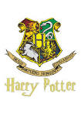
The School Council have organised a Harry Potter day on Thursday 8th February.
The children can come into school on that day dressed as a character from Harry Potter for £1.
There will be exciting activities available during the day, including a photo booth, games and competitions for 20p and a magical potion (drink) & biscuit to buy for £1.

ATTENDENCE
Attendance figures for this week are:

Year 6 | 91.96%
Reception | 91.82%
Year 1 | 90.37%
Year 4 | 90.00%
Year 5 | 86.43%
Year 2a | 84.12%
Year 3 | 83.15%
Year 2b | 73.75%

Well done to Year 6 who our winners for this week with 91.92%.

Will we get a class with 100%?
Who will the winners be next week?
Watch this space ……….

