HARVEST
Many, many thanks to everyone who donated tins and packets towards last week’s Harvest Celebration. Special thanks must go to Imogen Dukes’ Nanna, Janet Randall who made this astounding Harvest loaf which she made and sent in to school. It made a fantastic centerpiece.
The production of ‘Harvest Hope’ was fantastic and George Kane’s telling of the jokes was enjoyed by all. Just as your child to share them with you as they are basic but fun!
All of the goods collected were sent to The Storehouse Food Bank and were gratefully received by the volunteers there. They will go to give hope to families who are currently needing support.

UNIFORM
Please ensure that all times (apart from non-uniform days) your child wears the correct uniform. Standards of dress are slipping. As a reminder the correct uniform is:
Uniform (compulsory)  Red sweatshirt with logo  Red cardigan with logo(girls)  Red polo shirt with logo  Grey skirt/trousers  Sensible black school shoes  (no trainers). |  | P.E. Kit: (compulsory)  A red T-shirt with logo  Dark, preferably Black shorts  Black pumps for indoors P.E.  Trainers for outdoors P.E.  School logo track suit for outdoor P.E. which may be worn on Thursday and Fridays.

INCLEMENT WEATHER
Now that the weather is getting colder please ensure that your child has a warm/waterproof coat with them at all times.
PHOTOGRAPHER
Academy Photographers will be in school on Monday 17th October to take photographs of all the children individually as well as family groups and/or sibling groups.
If you would like your picture taken with your children or would like a younger pre-school child to be photographed with your older children please go round to The Studio (where we usually hold Coffee Mornings) from 8:15am. There may be a queue, but please be patient, the photographers are usually quick.
Children and those with brothers and sisters that are in school, including those in the Nursery, will be collected in turn to be photographed together.

PARENT’S CODE OF CONDUCT
At Marlfields Primary Academy we are very fortunate to have a supportive and friendly parent body. Our parents recognise that educating children is a process that involves partnership between parents, class teachers and the school community.
We would like to remind all parents, carers and visitors to

our school about the expected conduct. This is so we can continue to flourish, progress and achieve in an atmosphere of mutual understanding.
We expect parents, carers and visitors to:
· Respect the caring ethos of our school
· Understand that teachers and parents need to work together for the benefit of their children.
· Demonstrate that all members of the school community should be treated with respect and set a good example in their own speech and behaviour i.e. no foul language.
· Seek to clarify a child’s version of events with the school’s view in order to bring about a peaceful solution to all issues.
· Correct your own child’s behaviour especially in public where it could otherwise lead to conflict, aggressive or unsafe behaviour.
· Approach the school to help resolve any issues.
· Avoid using staff as a threat to correct
children’s behaviour.
In order to support a peaceful and safe school environment the school cannot tolerate parents, carers and visitors exhibiting the following:
· Disruptive behaviour which interferes or threatens to interfere with the operation of a classroom, office area or any other area of the school grounds including during team matches.
· Using loud/or offensive language, swearing, cursing, or displaying temper.
· Threatening to do harm to a member of school staff, Governor, visitor, fellow parent/carer or pupil regardless of whether or not the behaviour constitutes a criminal offence.
· Damaging or destroying school property.
· Sending abusive or threatening e-mails or text/voicemail/phone messages or other written communication.
· Defamatory, offensive or derogatory comments regarding the school or any of the pupils/parent/staff, at the school on Facebook or other social media sites. Any concerns you may have about the school must be made through the appropriate channels by speaking to the class teacher, Headteacher or Chair of Governors, so they can be dealt with fairly and effectively for all concerned.
· The use of physical aggression towards another adult or child. This includes physical punishment against your own child on school premises.
· Approaching someone else’s child in order to chastise them for any reason.
· Smoking and the consumption of alcohol or drugs whilst on school property.
· Dogs being brought on to school premises.
Should any of the above behaviour occur on school premises we may feel it necessary to contact the appropriate authorities and maybe even ban the offending adult from the school grounds. We trust that parents and carers will assist our school with the implementation of this policy and we thank you for your continuing support of the school.

Inappropriate use of Social Network Site
Social media websites are being used increasingly to fuel campaigns and complaints against schools, Headteachers, school staff, and in some cases other parents/pupils. The Governors of Marlfields considers the use of social media websites being used in this way as unacceptable and not in the best interests of the children or the whole school community.
In the event that any pupil or parent/carer of a pupil of this school is found to be posting libelous or defamatory comments on Facebook or other social network sites, they will be reported to the appropriate 'report abuse' section of the network site. All social network sites have clear rules about the content which may be posted on the site and they provide robust mechanisms to report activity which breaches this. The school will also expect that any parent/carer or pupil removes such comments immediately.
In serious cases the school will also consider its legal options to deal with any such misuse of social networking and other sites. Additionally, and perhaps more importantly is the issue of cyber bullying and the use by one child or a parent to publicly humiliate another by inappropriate social network entry. We will take and deal with this as a serious incident of school bullying. Thankfully such incidents are extremely rare.

CLOWN CRAZE
A Notice from Cheshire Constabulary:
We are aware of the current trend in America of people dressing up as clowns, which has reached the UK and received some publicity in the media.
We have a received a very small number of reports relating to this phenomenon, here in Cheshire, and we’re also aware of rumours that are circulating on social media.
While we appreciate that Hallowe’en is just a short time away, scaring people – especially children and vulnerable people – in this way is completely unacceptable and could constitute an offence.
Anyone who sees any suspicious activity, or who have been intimated or upset by this behaviour, should call Cheshire police immediately on 101.
PC Liz Stanton MBE - Lead Youth Engagement Officer

RESTART A HEART DAY
Thank You for your support during our a fundraising to help us to raise £759 to buy a Defibrillator for the school which can be used in the event of someone suffering a cardiac arrest. We have made a good start but we’re still not there so we will continue till we are successful!

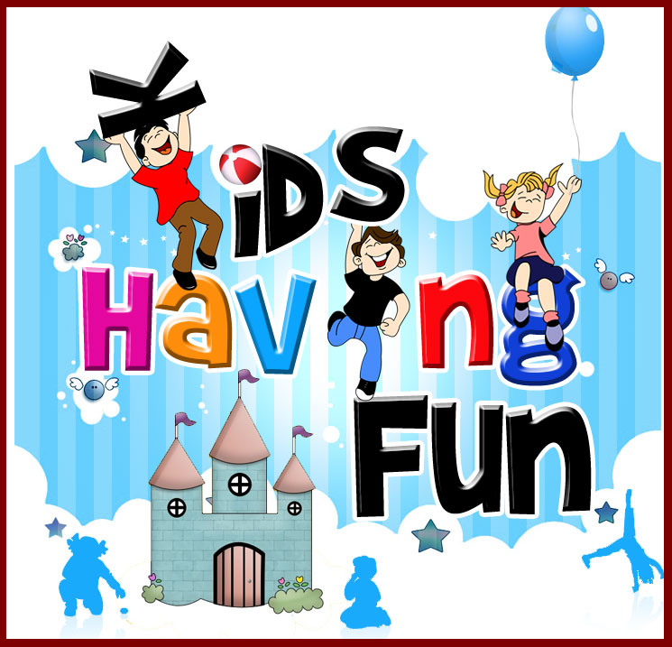
Trinity Methodist Church

Invite you to a
Family Time 4 You After School Club
for
children, parents, grandparents, carers
to enjoy
refreshments, songs, stories, activities.

1st and 3rd Tuesdays each month
From 3:30pm to 4:30pm
Starting Tuesday October 4th 2016

Cost: £1 per family.

Everyone welcome.
2016 dates:
Oct 4th & 18th
Nov 1st & 15th
Dec 6th & 20th

