EAST CHESHIRE HOSPICE ELF RUN
You are all invited to an assembly in the school hall presented by staff from the East Cheshire Hospice on Tuesday 29th November at 2:00pm. They are coming to talk to us about the work that they do and what they will be able to do with the monies that we hope to raise for them at our Elf Run which will take place at 2:00pm on Tuesday 20th December.
Four years ago we did a Reindeer Run and we managed to raise just over £1,800 for the charity; with your help this year wouldn’t it be fantastic if we could beat this amount.

SWITCH OFF FORTNIGHT
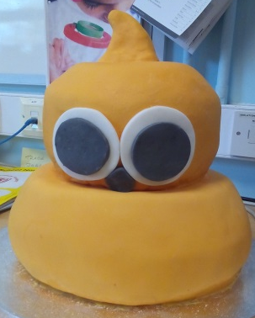
This week and next is part of Switch Off Fortnight. We are trying to encourage the children and staff to save energy. To help us to celebrate this Miss Holland has made this lovely cake for us to share.
Did you know that you can get a free smart meter which shows you the amount of energy you are using and how much it costs?
Simply contact your energy supplier to register your interest.

ANTI-BULLYING WEEK
This week has also been Anti-Bullying Week. During the week we have been focussing on our behaviour towards others. Each day children who have shown kindness or done a good deed for someone that has been noticed has been given a small sweet reward. We have had Malteser Monday, Twirl Tuesday, Wispa Wednesday, Twix Thursday and Flake Friday.
To finish the week, Miss Booth held an ‘Appreciation Assembly’ and showed our ‘Appreciation Hedgehog’ – a hedgehog which has messages of appreciation written on lollipop sticks for the prickles. Why not pop in on ‘thumbs up Thursday’ to have a look at it?

COLDER WEATHER
Now it is getting colder, please ensure that your child has a warm winter coat with them every day including Thursdays and Fridays when they are wearing their tracksuits. If it should snow heavily, and we make the decision to close school we will endeavour to text all parents to let you know or you can check the local radio station Silk FM 106.9 or check their web-site for details of closure.

ATTENDANCE
Year 3 | 97.65%
Year 6 | 96.84%
Year 2 | 96.26%
Year 1 | 95.94%
Reception | 95.23%
Year 5 | 94.88%
Year 4 | 94.73%

Well done to Year 3
who are this
week’s winners with 97.65%

GOOGLEBOX
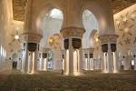
This week Years 2 - 6 went on a virtual tour of the Sheikh Zayed Grand Mosque which is in Abu Dhabi, the capital city of the United Arab Emirates, went in a cage and dived with sharks and even went to Base Camp at Everest with the last 2 experiences being “very scary” according to Sam and Ellie!
These experiences were achieved by using an I-Pad and a special 3-D viewer. The viewers are relatively inexpensive, in fact you can buy them from a number of outlets and support Children in Need at the same time.

HEADTEACHER’S CHALLENGE
Last week’s puzzle: In a one-storey pink house, there was a pink person, a pink cat, a pink fish, a pink computer, a pink chair, a pink table, a pink telephone, a pink shower– everything was pink! What colour were the stairs?

The answer is: It’s a one-storey building so
there are no stairs.
Unfortunately there were no winners this week.
This week’s puzzle is ………….

What is at the end of a rainbow?

Send your answers in on a piece of paper with your name and class written on it next week.

BLOOD DONATIONS
There is a severe shortage of blood donors at all times, but especially at this time of year. We have been asked by the Blood Transfusion Service to promote their next session which takes ay Congleton Town on Monday 5th December. There are two sessions, 1:45pm – 4:15pm and 5:30pm – 7:45pm.

CHRISTMAS LIGHTS SWITCH ON
Come along to the stage in the town centre next Friday (25th November) to listen to the Marlfields Choir singing from 4:15pm.

DATES FOR YOUR DIARY

DATE |  | EVENT | TIME
01.12.16 | Friends of Marlfields Film Night |  | 3:30pm
07.12.16 | Key Stage 1 Christmas Production |  | 6:00pm
13.12.16 | EYFS Christmas Production |  | 9:30am
14.12.16 | Key Stage 2 Christmas Production |  | 6:00pm
19.12.16 | Christingle Service  School Christmas Lunch  East Cheshire Hospice ELF RUN |  | 9:30am
Noon

2:00pm

