ANTI-BULLYING WEEK
13TH – 17TH NOVEMBER
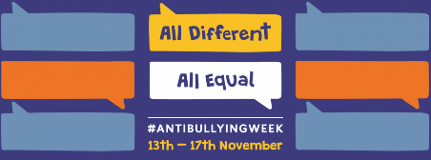
Next week is Anti-Bullying Week. During the week there will be lots of activities to raise awareness of diversity – how everyone is different and behave differently with the tag-line ‘All Different, All Equal’.
The idea is to help children and young people celebrate what makes them, and others, unique and help them to understand why it’s important that every child feels included in school able to be themselves without fear of bullying.
On Friday to celebrate differences we would like the children to come to school wearing ODD SOCKS! There will also be an assembly on Friday 17th November at 2:30pm – parents are welcome to come along to celebrate.

COLD WEATHER

Now that the weather is changing and getting colder, please remember to send your child into school with a warm winter coat and sensible shoes. Boots may be worn to school, but when the children are indoors they need to change their footwear to either shoes or their P.E. pumps. Please also ensure that your child has their P.E. kit in school every day so that if they get wet they will have something to change into.

CHILDREN IN NEED

A number of Year 6 children sent in letters to Mrs Isherwood earlier this week with a fund-raising idea. They wanted to help others by holding a Bake Sale, the proceeds of which they would send to Children in Need.
Mrs Isherwood was so impressed by their persuasive writing that she readily agreed for the Bake Sale to go ahead.
The cakes will be on sale on Wednesday 15th November both at break-time and lunch-time. Small cake and biscuits will cost 50p and larger cakes a £1. The children would be most grateful for any support.

