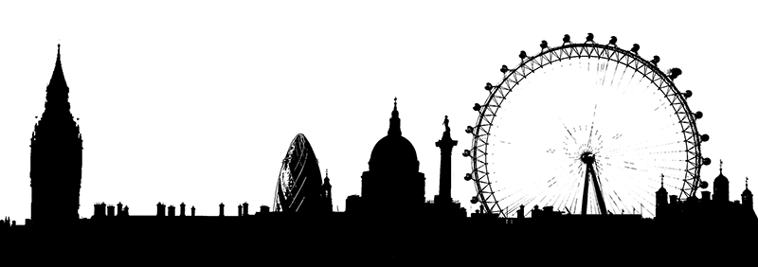
VISIT TO LONDON
By Lucy Janes
On Monday, 6th July, we had the most amazing day! It was finally the day of the trip to London! We arrived at Crewe Station at 7:30 in the morning. Even though I got up very early in the morning, it didn’t stop me from enjoying myself. At 9:45 we arrived in London, which I couldn’t wait to explore!

The first visit of the day was to the Houses of Parliament. We saw the 3 main parts of the building – the House of Commons, the House of Lords and the Centre Lobby. We found out lots of interesting facts about the building and about all of the artefacts.

After the Houses of Parliament we went onto the London Eye. We saw lots of famous buildings. We saw the Tower of London, Big Ben, St. Paul’s Cathedral, Buckingham Palace and The Shard. Then we went on a boat trip along the River Thames. We were very lucky as the weather was glorious.

After a busy day of walking and sailing we finally sat down on the train for our journey back home. On the train we had Nando’s for tea. I had a grilled chicken burger filled with lettuce and tomatoes served with chips.

That day will be a trip I will never forget. I found out interesting facts and have brought home some magical memories that I will always remember. I had a wonderful time and it will be treasured in my heart forever!

HEAD LICE
Once again the subject of Head Lice must be brought up. Currently most of the classes in school have reported cases of this annoying and irritating problem. Please take the time to check everyone’s head in the household for signs of live lice or their eggs (nits) and if any are found treat everyone in the household using your preferred method of treatment following the instructions to the letter.

If everyone were to check thoroughly on a regular basis and treat hair if the problem arises, then hopefully as a school we can be relatively ‘nit free’!

Copper Mile
Our “Copper Mile” takes place next Friday, 17th July. Each class is collecting copper coins to see who can collect the most. There is a prize for the class which collects the most coins.
Early indications show that Year 6 are still in the lead. Please remember to bring in your small change as “Every Little Helps”.

COFFEE MORNING
Also taking place next Friday is a Friends of Marlfields Coffee Morning, beginning just after 9:00am in the New Studio.
Come along for a brew and a cake and a natter with friends whilst raising funds to support your children. Everyone is most welcome to come – bring Granny, Grandad, Aunts, Uncles and friends as well – the more the merrier!

Donations of cakes would be most welcome. If you are willing to donate some, please bring them into school by the afternoon of Thursday 16th July.

