

**Marlfields Primary Academy**

**NEWSLETTER**

**26th May 2017**





AFTERNOON TEA

Come and join us for an

Afternoon tea on **Thursday,**

**15th June at 2:30pm.**

Year 6 will be organising this

as a fundraiser and is not to

be missed.

Watch out on the newsletter

for more information and

booking forms.

**THANK YOU**

We would just like to say ‘Thank you’ for the support over the last two weeks from many of you. We have been hit by a number of illnesses and events with many of our staff; which has resulted in absences of key personnel. Other staff have stepped up to the mark and kept us ticking over with enthusiasm, skill and professionalism. We would like to thank them in this newsletter for the extra work that this has entailed at an already busy time for them.

As we approach the half term we hope that when we return in June all will be back to normal.

Thank you to all of those who have sent good wishes for speedy recoveries they are very much appreciated. Staff return on the **5th June** for a staff INSET day and **children return on the 6th June.** Until then please keep safe and have a great half term break.

****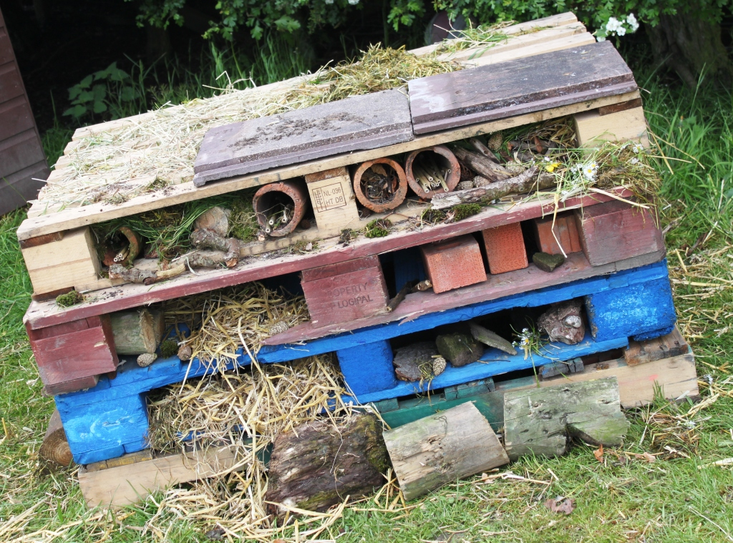

**The Bug Gardens**

**Free drop in workshops - Friday 2 June 2017**

**In the Community Polytunnel, Congleton Park**

**Session 1: 10:00am - noon**

Help design and build a bug hotel and bee homes

**Session 2: 1:00pm – 3:00pm**   
 Create your own bugs from recycled materials,

design a bug poster.   
 Plant a tree sapling to create a mini woodland.

Working with our local environmental educator,

Patti Pinto (Eco learning)

**Children under 8 must be accompanied by an adult**

**To book please call Martha on: 01260 270350**

**Abuse**

**of any kind is NOT acceptable, either through social media or on our grounds.**

**We will prosecute if necessary.**

**FOOTBALL CARDS**

**Can you please stress to your children that we do not allow them to bring Football Cards into school to be swapped or whatever; if we see any child with them in their possession they will be confiscated.**

**FREE RUGBY SUMMER CAMP**

Over the Summer Holidays **(Monday 31st July to Friday 1st September)** Congleton Rugby Club are running Summer Camps children in Congleton.

The clubs will run every day of the week on Hankinson's Field (next to Congleton Leisure Centre) at the following times:

**Mondays 10:00 - 11:00am** for Years 1 and 2,

**Tuesdays 10:00 – 12noon** for Years 3 and 4,

**Wednesdays 10:00 – 12noon** for Years 5 and 6.

The Camps are completely free, no booking is required and children can just turn up on the day.

No previous Rugby experience is necessary, in fact the more beginners the better!

The coaching will be provided by our Junior Director of Rugby, Tommy Banks, who has worked in several local schools already to provide coaching and is an RFU level 2 coach and fully DBS checked.

Look forward to seeing you all!

**WANTED**

You may be aware that we are again exhibiting at the RHS show at Tatton Park. For the display we ask if you have any **OLD wellies or walking boots** that you would like to donate for us to use in our display.

****

|  |  |  |
| --- | --- | --- |
| **TERM DATES 2016 – 2017**  **Last Day In School School Opens** | | |
| **Summer Half Term** | **Fri 26.05.17** | **Mon 05.06.17**  **INSET DAY** |
| **Tue 06.06.17**  **Children in** |
| **Summer Holidays** | **Tue 25.07.17** |  |

|  |  |  |
| --- | --- | --- |
| **TERM DATES 2017 - 2018** | | |
| **Autumn Term** |  | **04.09.17**  **15.09.17**  **INSET DAY** |
| **Half Term** | **20.10.17** | C:\Users\SCA8752170\AppData\Local\Microsoft\Windows\Temporary Internet Files\Content.IE5\0F4G5DFC\good_sun1[1].jpg**30.10.17**  **INSET DAY**  **31.10.17** |
| **Christmas** | **20.12.17** | **08.01.18** |
| **Half Term** | **15.02.17**  **16.02.18**  **INSET DAY** | **26.02.18** |
| **Easter** | **30.03.18** | **16.04.18** |
| **Half Term** | **25.05.18** | **04.06.18**  **INSET DAY**  **05.06.18** |
| **Summer Holidays** | **24.07.18**  **25.07.18**  **INSET DAY** |  |

**DATES FOR YOUR DIARY**

|  |  |
| --- | --- |
| **26th May** | **Break up for half term holiday** |
| **5th June** | **INSET Day** |
| **6th June** | **Children back into school** |
| **26TH June** | **Reception Class Assembly** |
| **29th June** | **Barclays Bank Experience**  **Yr 6 Transition Day to CHS Yr 6 only** |
| **5th July** | **Sports Day** |
| **6-7th July** | **Yr 6 Transition Day to Eaton Bank Yr 6 only** |
| **7th July** | **‘Move Up’ Day Rest of school** |
| **14th July** | **Reports out** |
| **17th July** | **Yr 6 Performance** |
| **19th July** | **RHS Tatton Show** |
| **21st July** | **Fun Day Yr 6 only** |
| **24th July** | **Prize Giving Assembly** |
| **25th July** | **SCHOOL CLOSES FOR SUMMER HOLIDAYS** |

**FINAL WORD**

Please all enjoy the half term holiday, fingers crossed the nice weather will hold so that we can all get a good bit sunshine on our bodies and lots of fresh air in our lungs! Remember to not be in the sun for too long, use a good sun screen and wear a sun hat and keep in the shade as much as

possible.





C:\Users\SCA8752170\AppData\Local\Microsoft\Windows\Temporary Internet Files\Content.IE5\ZDT1TIN6\sun_hat_green_by_clipartcotttage-d7a32b6[1].gifC:\Users\SCA8752170\AppData\Local\Microsoft\Windows\Temporary Internet Files\Content.IE5\LKXY7OG5\sun_hat_green_by_clipartcotttage-d7a32b6[1].gif

R:\Scanned Documents\SKM_C284e17052514520.tif

****

Congleton Town FC & Local Schools

A Perfect Partnership!

Our school is proud to announce a new & exciting partnership with Congleton Town Community Football Club. Congleton Town Community Football Club (CTCFC) are your local semi-professional team currently playing in the Hallmark Security Premier League - that's just five divisions below the National Football League.

With your support, we can produce a local team to be proud of & also raise money to provide new equipment in your child‘s school. For every paying adult entering a CTCFC league game, not only will your child / children be able to enter for free, the school will receive half of the adult entry price - that's **currently £3 donated back to the school** every time you come along to cheer on the team!

We as a school are very keen to explore this opportunity. Let's say that 20 adults associated with our school take their children along to watch 20 home games… that would be a return of £1,200, all of which would be spent on improving equipment & facilities. To register interest & receive a match-day entry card, please add your details to the form below & return to school via your child.

On behalf of the School & CTCFC ……………………… **Thank you for your support!**

**✄-------------------------------------------------------------------------------------------------------------------------**

Name(s) of child / children: \_\_\_\_\_\_\_\_\_\_\_\_\_\_\_\_\_\_\_\_\_\_\_\_\_\_\_\_\_\_\_\_\_\_\_\_\_\_\_\_\_\_\_\_\_\_\_\_\_\_\_\_\_\_\_\_\_\_\_\_\_\_\_\_\_\_\_\_\_\_\_\_\_\_\_\_\_

Class: ­­­­­­­­­­\_\_\_\_\_\_\_\_\_\_\_\_\_\_\_\_\_\_\_\_\_\_\_\_\_\_\_\_\_\_\_\_\_\_ Name of Parent / Guardian: \_\_\_\_\_\_\_\_\_\_\_\_\_\_\_\_\_\_\_\_\_\_\_\_\_\_\_\_\_\_\_\_

**Yes - Please provide me with a match day pass!**

Our school will pass on this form to CTCFC who will then send us your pass which we will send home with your child.

**TERM DATES 2016 - 2017**

**Last Day In School School Opens**

|  |  |  |
| --- | --- | --- |
| **Summer Half Term** | **Fri 26.05.17** | **Mon 05.06.17**  **INSET DAY** |
| **Tue 06.06.17**  **Children in** |
| **Summer Holidays** | **Tue 25.07.17** |  |

**TERM DATES 2017 - 2018**

**Last Day In School School Opens**

|  |  |  |
| --- | --- | --- |
| **Autumn Term** |  | **04.09.17**  **15.09.17**  **INSET DAY** |
| **Half Term** | **20.10.17** | **30.10.17**  **INSET DAY**  **31.10.17** |
| **Christmas** | **20.12.17** | **08.01.18** |
| **Half Term** | **15.02.17**  **16.02.18**  **INSET DAY** | **26.02.18** |
| **Easter** | **30.03.18** | **16.04.18** |
| **Half Term** | **25.05.18** | **04.06.18**  **INSET DAY**  **05.06.18** |
| **Summer Holidays** | **24.07.18**  **25.07.18**  **INSET DAY** |  |