UNIFORM
The other day we had a visit from our Chair of Governors and she commented on how many children were not wearing their school uniform. Having looked round we realised that she was right! We would like to stress that full uniform is compulsory (unless we have a non-uniform day like today!). Children are permitted to wear their school tracksuit ONLY on the days that they do PE and on no other day. If you are unsure on what day your child’s class does PE please write a short not in your child’s planner to find out.
As a reminder the school uniform comprises of:
Uniform (compulsory)
Red sweatshirt with logo
Red polo shirt with logo
Grey skirt/trousers
Sensible black school shoes
(no trainers).
Please check with your child’s teacher should you be unsure of your child’s PE day.

UNIFORM CHANGE SEPTEMBER 2017
We are introducing a different skirt for the girls to wear instead of plain grey from September 2017, please see the design below. We hope you love it as much as the children do.
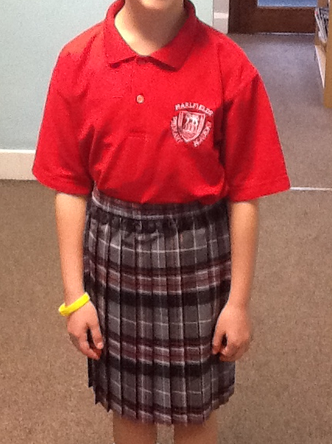

The governors have approved the design of the skirt and the cost will be £5 and available to purchase from school.
If parents have any objection, please email your objection to admin@marlfields.cheshire.sch.uk before the 18th April stating why you object. After that date we will inform you of the next steps.

LEGOLAND VISIT &
NATIONAL DOWNS SYNDROME WEEK
Just one week to go before our exciting visit to Legoland at the Trafford Centre! We are all getting excited!
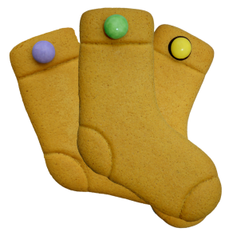
Next week is also the National Down’s Syndrome Awareness Week and as part of this they have asked if we would sell gingerbread socks to the children to help raise awareness of Down’s Syndrome as well as raising much needed funds for the charity. We thought it would be a nice idea to sell the socks to the children on the same day as the Legoland visit so that they can have them as a snack. We are selling the socks at £1 each, so if you would like your child to have one please send in £1 in a named envelope. There are limited amounts, so they will be given out on a first come, irst served basis.

SICKNESS BUG
We would like to remind parents that your child MUST be kept off school for 48 hours AFTER the last time he/she was sick. Please also emphasise to them that they should thoroughly and regularly wash their hands to prevent reinfection.

EASTER BINGO
Don’t forget to put Thursday March 23rd into your diary to come along to have a game of BINGO in the school hall from 5:30pm. These BINGO evenings are great fun, so come along for a laugh, a brew AND the chance to win over 180 Easter Eggs.

GROUP PHOTOGRAPHS
Academy photographers came into school this week to take class photographs. The proofs have been returned for us to distribute. Should you wish to buy copies of your child’s class photo please return the proof and envelope complete with payment to the office by Thursday 30th March. Please send in the correct money as the envelopes are not opened in school but are sent direct to the photographer which means that we are unable to give change.

ATTENDANCE
This week’s Attendance is as follows:

Year 3 | 96.71%
Year 6 | 96.34%
Year 1b | 95.64%
Year 2 | 94.24%
Year 5 | 94.13%
Reception | 93.11%
Year 1a | 92.77%
Year 4 | 92.01 %

Well done to Year 3,
who are this
week’s winners with
96.71%

HEADTEACHER’S CHALLENGE
This week’s puzzle is ………….

What is the longest word in the dictionary?
Send your answer in on Monday

The answer to the last riddle: What can run, but not walk? Water/river/tap

Well done Evie, Lequisha, Ellie and Mckenzie for sending in the correct answer.

PLEASE TURN OVER FOR MORE INFORMATION…….

