

**NEWSLETTER**

**25th July 2017**

**PRIZE GIVING**

Yesterday, Monday 24th July was our Annual Prize Giving Assembly. Prizes were handed out to children in Key Stage 2 for various achievements including Significant Academic Progress, Choir Person of the Year, Sports Personalities, School Progress, School Life, Kindness, Maths, Courtesy and environment.

The presentations were made by Mrs Liz Gowler who taught here when our current Year 6 were in the Reception Class and she was their first teacher. She will have noticed a huge difference in the children when she presented Year 6 with their certificates and gifts.

**Year 6 Production**

Wow! What a treat we all had last Monday night at the Year 6 production of “Jack and the Beanstalk”.

The children, Mrs Pearce and Mrs Wood all put so much into the production, and it showed, they were all so professional in their acting, singing and dancing. It was all so amazing! Some of us (me especially) had tears streaming down my face firstly of laughter and then emotion at how they all acted their hearts out.

Congratulations to you all for a brilliant performance!

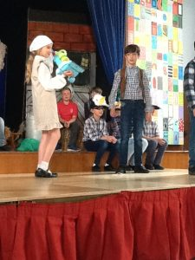

The Giant looking down on Jack and his Mum!

****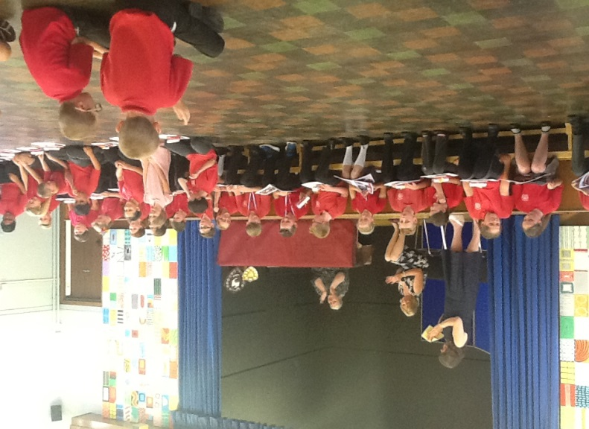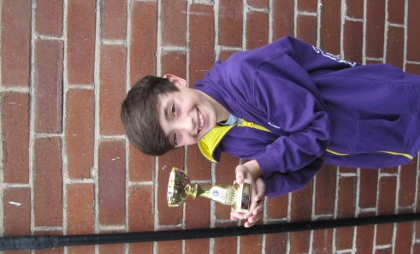

**Final words of this academic year………….**

Just to remind you all that the **first day back to school for the children in September is Monday 4th** even if other schools are on an INSET day**. Our INSET Day will be Friday 15th September.**

We hope that you all have a wonderful summer break.

Good luck and happiness to all of our leavers, staff and pupils alike.

Thank to everyone for their support over this past year, we look forward to your continued support next year.

**See you on Monday 4th September for the start of the exciting adventure of learning at Marlfields.**

**MUNCH & CRUNCH**

Munch & Crunch with the Reading Bunch will continue in September, but not until the 11th once we have sent the new enrolment form out to join the club.

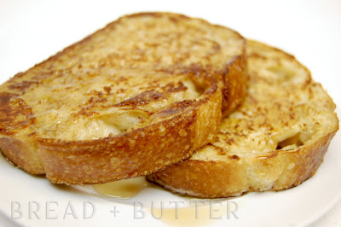 

Arran Wilkie proudly showing

off his drama award which he

recently received.

Arran attends a weekly drama

class and once a year they

do a performance at a

professional theatre.  Arran was the captain in the “The Bold Buccaneers” and after the performance received this trophy.

Congratulations Arran from all at Marlfields!