NEWSLETTER
17th July 2017

RHS TATTON SHOW

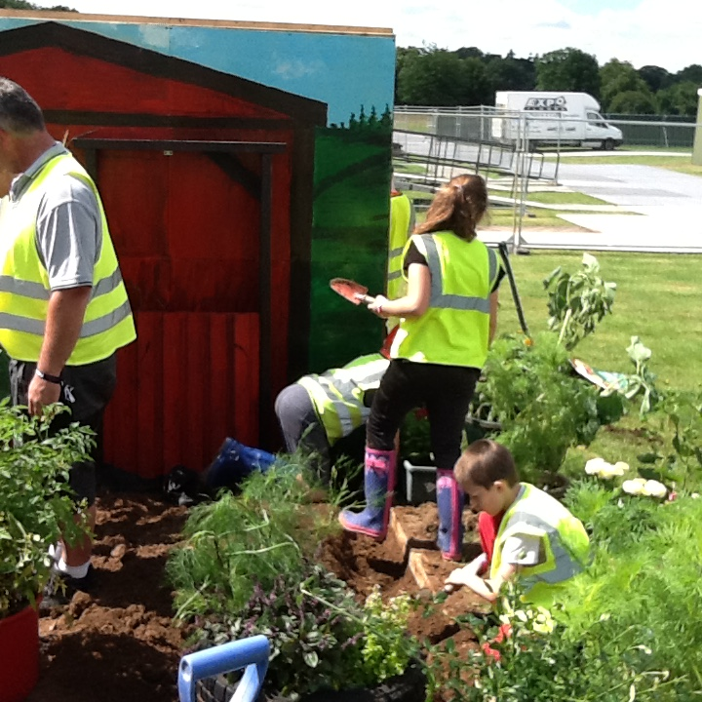
On Wednesday, children and staff went to the Tatton Park showground to build our entry for this year’s Royal Horticultural Society Tatton Flower Show. Our entry this year is using the story of Charlotte’s Web a wonderful story by E. B. White.
As you can see, the children were really enthusiastic with planting up and completing the finished article below. It looks really stunning.
The show takes place from 19th July until 23rd July should you wish to go along to see the display and vote for us. Keep your fingers crossed for us to win the coveted best in show garden!
Thanks must go to the children of the Eco Club, Mrs Abrahams, Mrs Daley and Mrs Gartside our Chair of Governors for all the work involved throughout the past few months with the planning of and the getting ready of our wonderful display.
We must also give thanks to Mrs Birch, who is one of our adult reading helpers for organising the donation of the lovely cold frame which will be enjoyed by school when it returns.

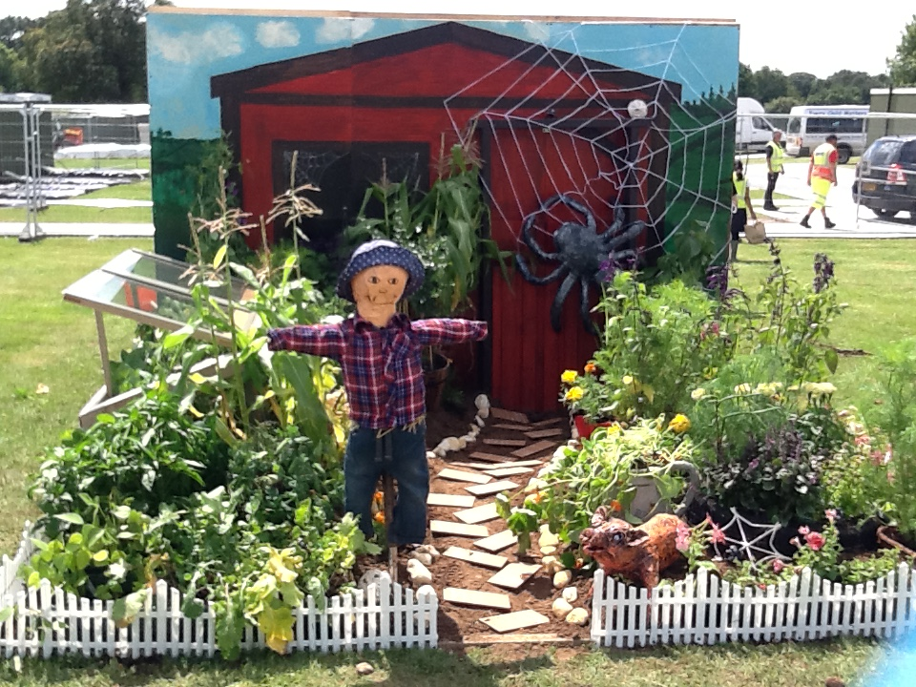
STAFF NEWS
As always, at this time of year staff decide to move on to pastures new, and this year is no exception.

Firstly we say goodbye to Mr Capewell, who joined us last year as a newly qualified teacher teaching Year 1B. He has secured a teaching post nearer to where he lives.

Another member of staff leaving us is the newly married Mrs Norton (Miss Holland) who is leaving us after 7 years to take a change of career path and to do some further studying.

We wish both of them all the very best for the future and for their new ventures.

TOWN SPORTS
The week before last Marlfields took part in the annual Town Sports Competition at Congleton Town Football Club. This is an athletics event between all of the primary schools in Congleton.
Although we didn’t win the completion overall we did have a number of medal winners who were; Bethany Fletcher, Chloe Gillett and Leighton Wilson. We would like to congratulate these three on their achievement and say a huge well done and thank you to the rest of the squad for taking part and doing their very best against strong opposition; and to Mums and Dads for cheering you all on and supporting our team.
P.T.O.
MEDAL WINNER
Please join us in congratulating Alfie Brewer from Year 6 who recently gained third place for his age group in the National Championships for Back to Back which is a form of martial art. As you can see Alfie is very pleased with his achievement.

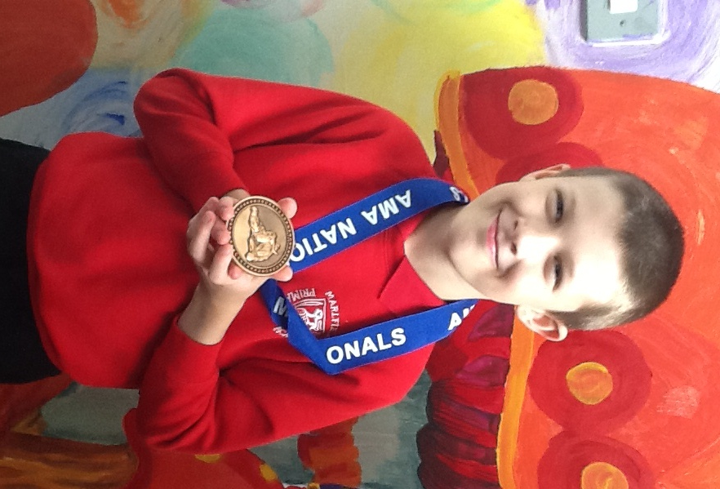
Do you have something that you would like to celebrate and tell the whole school? Either call in to the office with details, or email us on admin@marlfields.cheshire.sch.uk and we will do our best to include it on the next Newsletter.

Congleton Library 2017
Summer Reading Challenge.

This summer, Congleton Library is running a reading challenge: 6 weeks, 6 books, linked to the topic ‘Animal Agents’.

Last week our children enjoyed an assembly from Jenny from the library who introduced them to the challenge.
Your child needs to be signed up for the challenge and on completion if they have read 6 books they are given stickers, a certificate and a medal in early September.

On 7th July during our ‘Meet the Teacher’ event staff further encouraged parents to sign their child up to this summer reading challenge and included a brief introduction within the class information leaflets given.

Throughout the summer Congleton Library offers guidance on supporting your child with reading and motivation to complete the challenge by giving incentives when the children visit to change their books. We cannot stress enough the importance for all our children to continue to read throughout the summer holiday.

As in previous years school will further motivate your child to have a go and take part in the Challenge. On completion of the ‘Animal Agents’ challenge if the children who read the 6 books, during the 6 weeks bring their medal and certificate into school when we return in September our Chair of Governors, Margaret Gartside will also congratulate the children with a further reward from school. One year this was a cinema voucher, another a reading voucher and last year children who completed the challenge were taken to the cinema in Stoke for a movie and popcorn.
Who knows what this year’s reward will be, but it’s worth taking part and reading a few books and getting rewarded for doing so. Please take time to read the leaflet sent from Congleton Library handed out with this week’s newsletter.

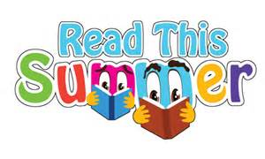
Should you have any questions please ask by, either emailing the school, phoning the office or coming to speak to Mrs Stapleton our reading staff champion in school.

Good Luck and we look forward to seeing all the certificates and medals in September.

