FRIENDS OF MARLFIELDS
The next meeting of the Friends of Marlfields will be on Friday 3rd February at 3:30pm.

All families of pupils at our school are members of the Friends of Marlfields group (FOM).
WHAT IS FOM?
The Friends of Marlfields is a group of parents that run regular fundraising and social events for the whole school community. Our fundraising efforts have enhanced the education and experience of all the children at the school and will continue to do so with your support.
During the year we run a number of events such as School Discos, Coffee Mornings, Film nights and class enterprise events to help raise funds. The money raised supports Christmas celebrations and gifts for the children, sports kits; bring theatres into school and towards making trips slightly cheaper for you as parents.
Why do we have a Friends of Marlfields Group?
The Friends of Marlfields is an integral part of the school community and has raised thousands of pounds, which has been spent on equipment and resources to enhance our children’s education experience and the school’s facilities.
The Friends of group exists to provide closer links between home and school and it is an excellent way to bring staff, parents, carers and friends together socially in support of the school, working towards a common goal. It is fun too – just ask any committee member or Friends of Marlfields helper.
We like to encourage everyone to get involved, by attending events, donating items needed or helping run events by giving up some of their free time, even if they only have a small amount of time available.
Not all our events are run as fundraisers. Our family events are run with the aim of giving the children a good time and as a way of thanking families for their continued support for the Friends of Marlfields group.
HOW you can get involved?
Offers to help before events or at other times during the year are always greatly received.
It doesn’t matter if you can’t help on a regular basis there are often small jobs that just need a few minutes of your time – let us know if you have half an hour to spare e.g. wrapping gifts, preparing raffle tickets, shopping etc. We really couldn’t achieve what we do within the behind the scenes help that we receive.
If you would like to be more involved, you can volunteer to be a Class Representative, Committee member or you can simply support the meetings by giving us your ideas for fundraising events; this is also the time to ask questions or voice your opinions.

SCIENCE DAY
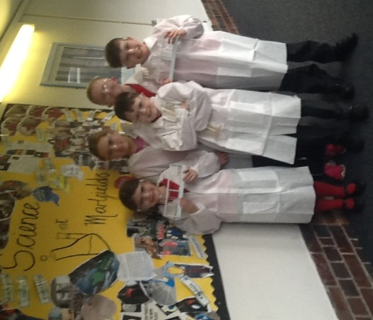
At Black Firs Primary on Thursday, 26th January, six of our Year 4 students attended a Science Day which was hosted by AstraZeneca. They had a wonderful morning conducting science and biology experiments.
Aly Whalley, Natalie Barber, Oliver Hibbitt, Jayden Wood, Lucas Benson and Jayden Archer all took part in three exciting experiments:
The first was to pour measured water into a clean plastic bottle, then adding vegetable oil and a few drops of food colouring. The children identified that the oil and water did not mix … until they shook it up – and then it resembled a chocolate milk shake! Jayden Archer loved this one because it was funny how the mixture looked, but it wouldn’t have been good if you drank it.
The next experiment was the making of a Lava Lamp which the children found fascinating. Like the first experiment, measured clean water was poured into a clean plastic bottle, the vegetable oil was added and food colouring. And then a sodium bicarbonate tablet was added to the mixture. The fizzy tablet forced the oil and water to mix with the food colouring in the bubbles. Natalie, Aly and Jayden Wood’s favourite part was making the lava lamp because it was amazing how one tablet could make such a big difference. There were clear steps to follow but it was entertaining and fun.
The final experiment was so exciting as the children extracted the DNA from a banana! Lucas loved this bit the most because it was a challenge getting the sticks in the right place because the banana was wobbling everywhere.
A lovely morning of learning for all the children and our thanks go to Black Firs and AstraZeneca.

GIRLS FOOTBALL
On January 27th the Girls Football team took part in the County Finals of the EFSA Danone Under 11 7-a-side Girls Competition in Crewe. They played exceptionally well, getting through to the quarter finals, meaning that they were in the top eight of the county! Well done girls on your achievement!

YOUNG VOICES
On Wednesday most, although not all, Year 5 & 6 are going to the Manchester Arena to take part in one of the world’s largest school choir concerts in the world.
The concert is usually featured on one of the local news programmes, so watch out for us!

