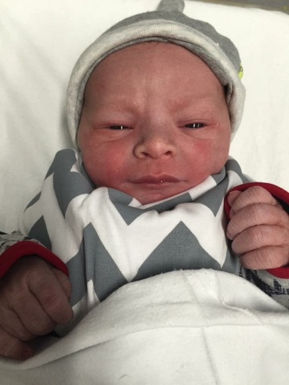

**IT’S A BOY!!!!**

We are pleased to let you know that Miss Booth has given birth to a beautiful baby boy. He was born on Thursday 14th January. He weighed a very healthy 9lb. Mother and baby are both doing very well.

We are sure that you will join us in wishing Miss Booth, her partner and baby Bruce well.

**School Uniform**

From the beginning of this term we have noticed that some children are not wearing school uniform items that meet the requirements of the school uniform policy. The main items where there appears to be some discrepancy are:

* Not wearing the red school polo or red P.E. t-shirt underneath their school tracksuits on our PE days,
* P.E. days are Thursday and Friday and school tracksuits only may be worn for these days. (**Please note that football shirts/kits should not be worn in school for PE lessons**.)
* P.E. wear is a red t-shirt and black shorts. Warm clothing can be used for the P.E. lesson but **only** school logo tracksuits can be worn for the whole day. (**Please note that football shirts/kits should not be worn in school for PE lessons**.)
* School tracksuit tops are not a suitable outdoor coat as they are not fully waterproof or warm enough for the weather we are experiencing at this time.
* No hoodies to be worn at any time, even red ones.
* Footwear: Plain black shoes in a sensible style (flat heels) that are safe for running and for playing in. Boots may be worn for the journey to and from school and out at playtime, but we ask that your child has a pair of black pumps in school that they can wear indoors to protect our carpets.

We would appreciate parents fully supporting the school’s uniform policy. Letters will be sent home if your child’s uniform does not meet the school uniform policy when teachers make their checks.



**Operation Encompass**

We would like to inform you that our school is participating in a Police-led initiative called Operation Encompass; which is a scheme which will ensure that we can we can better support any child where a domestic incident has been reported to Police from their home.

Following a domestic incident, the Police will make contact with the school via telephone and communicate relevant information to nominated, fully-trained school staff. This will ensure that we are made aware early enough to support children and young people in a way that means they feel safe, supported and listened to. This scheme went live on the 4th January 2016. You can find out more about Operation Encompass via the following site: http://www.operationencompass.org

If you would like to speak to someone further about the initiative, or require any additional information, please do not hesitate to contact Mrs Isherwood or Miss Carr, the school’s designated safeguarding leads.

We are committed to working in partnership with local relevant organisations to safeguard and protect children across Cheshire and provide the best possible care and support for our pupils.

**CLUBS**

Clubs will begin next week. Your child will bring home with them a slip confirming whether they have a place at their chosen club(s).

**Cooking Club** is as popular as ever, and we are massively over-subscribed. To avoid the children of Key Stage 1 being disappointed in the Summer term when it is their turn to cook we wondered if there are any parents or grandparents who would be willing to come along to help out on a Wednesday after school. If you would like to help out please leave your name at the office.

**ATTENDANCE**

Attendance figures for this week are:

|  |  |
| --- | --- |
| **Year 6** | **97.15%** |
| Year 2 | 96.96% |
| Year 4 | 96.53% |
| Year 3 | 96.45% |
| Year 5 | 95.95% |
| Year 1 | 95.48% |
| Reception | 94.16% |

**Well done to Year 6 who are this week’s winners with just over 97%.**

Who will the winners be next week?

Come on, we need to get a class with 100%!

Watch this space ……….

Thank you to everyone who sent in an answer to last week’s challenge. The winner will be announced at Monday’s Celebration Assembly

**THIS WEEKS challenge**

**Is 0 (zero) an odd or an even number?**

Send the answer into school on Monday with your name and class on it and one correct answer will be rewarded with a treat - this will be drawn by raffle if more than one correct answer comes in. Get your thinking caps on for the correct answer and good luck to you all!

**SCIENCE DAY**

By Thomas Hatton

On Wednesday 13th January the Science Boffins came to our school and gave us a treat! We started the day with an exciting assembly led by Harry, producing some amazing experiments for us.

Throughout the day each class completed a workshop with plasma balls, slime and fire. At the end of the day everyone went out onto the playground to set a rocket launch into the sky.

Overall, it was a great day for everyone and we hope the Science Boffins enjoyed meeting us as much as we enjoyed meeting them!!



**SCHOOL HOLIDAYS**

|  |  |  |
| --- | --- | --- |
| **February 2016 Half Term** | **Fri 12.02.16** | **Mon 22.02.16 INSET**  **Tue 23.02.16** |
| **Easter 2016** | **Thu 24.03.16** | **Mon 11.04.16** |
| **Summer Half Term 2016** | **Fri 27.05.16** | **Mon 06.06.16 INSET**  **Tue 07.06.16** |
| **Summer Holidays** | **Wed 20.07.16** |  |

