PARENTS EVENING
Many thanks to everyone who attended their child’s Parent’s Evenings this week. If for any reason you were unable to attend, please ring the office on 01260 387057 and we will do our best to arrange an alternative appointment for you to talk to the teacher about your child’s progress.

HARRY POTTER DAY
By Thomas, Year 6
On Thursday we held our Harry Potter Night of Spells. All the classrooms had different events in them such as Quidditch, Potion Making, Wand Crafting, Owl Making From Balloons and lot more. In the Hall there was refreshments, Pin The Glasses on Harry Potter which was a twist on the game Pin The Tail On The Donkey, Wizarding Duels and Memory Charms. A fun time was had by all and we hope we can hold similar events in the future.
Thank you to everyone who took the time to come in costume and to enjoy the fun with us.

POP PROJECT
By Amber and Thomas, Year 6

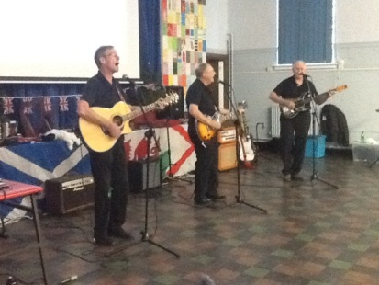
Last Friday a group called the Pop Project came to do an assembly in our school about British Values. They did a great job on showing all of the different British values and meanings of them.
The assembly was divided into different segments, one for each different part of Great Britain: Scotland, Wales, Northern Ireland and of course, England!
To introduce each country there was a song that all the teachers had to guess the artist of. Most of the teachers didn’t bother guessing and some did, Ms Dixon guessed nearly all of them!
The Pop Project sang a lot of songs that were very funny, some of them the children knew and some, they didn’t. Some of the songs were called Yellow Submarine; We Are Family, Roar, Rather Be, 500 Miles, Love Train and another is I’ll Get By With A Little Help From My Friends.
The children enjoyed it so much it was a brilliant performance from this group, definitely.

SAFER INTERNET DAY
Tuesday 9th February has been designated as Safer Internet Day. Please take 5 minutes of your time to visit our web-site – www.marlfields.cheshire.sch.uk in order to read about safe internet usage for yourself and your child.

ATTENDANCE
Attendance figures for this week are:

Year 5 | 98.90%
Year 4 | 98.32%
Year 2 | 98.29%
Year 6 | 98.29%
Year 1 | 97.81%
Year 3 | 95.24%
Reception | 94.37%

Well done to Year 5 who are this week’s winners with 98.90%.

Who will the winners be next week?
We still haven’t managed to have a class with 100% Attendance.
Come on ………….. we need to have a class with 100% so we can have a huge celebration! P.T.O.

Barclays Code Playground

With half term approaching consider taking your child along to Barclays Bank to learn computer coding in a fun way on their Code Playground.

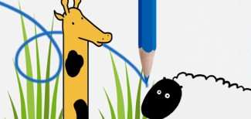
What is Code Playground?
Computer code runs our world – from the school website to the traffic lights on our roads. It’s now part of the national curriculum now, and learning what makes tech tick could give your kids a head start in the world of work.
Give them a helping hand by bringing them along to a coding session with Barclays Digital Eagles – experts who’ll guide your children as they take on fun challenges that introduce them to the basics of coding.

Get your kids involved today
Barclays have built an on-line playground where kids can start to discover coding. It's a safe place where young explorers can try their hand at fun activities that are based on simple coding principles. Whet their appetite today.

Book a coding session at your nearest branch
They also run monthly 2-hour coding sessions for children aged 7 to 17 in selected branches. It’s a really fun way to learn the basics and develop digital skills for the future. Take your children along with their laptops and Barclays Digital Eagles will help them discover coding.
They’re open to children aged 7 to 17. They’ll need to bring along a laptop, and an adult. Places are limited, so book ASAP

What is coding?
Coding is the language that we use to talk to computers and tell them what to do. It drives the software in every computer, gaming device, phone and camera, but you’ll find it in everyday household appliances too, from washing machines to the new ‘smart’ thermostats.

Why is it so important?
Digital skills are in demand – the number of job roles for IT professionals is likely to increase by 15% in the next seven years. Not everyone wants to become a programmer, but the skills coding teaches are invaluable to all kids. Coding is a way of thinking logically about a problem and piecing it all together; it helps us to learn a consistent way of thinking and developing a logical mindset. This can help with problem-solving and structuring arguments – skills essential in careers such as law and medicine.

In conclusion, we thought that this was an amazing experience for all of the school.

WEEKLY challenge
Well done to Isabella Hurst in Year 4 who was picked from the many correct answers to last week’s Harry Potter themed questions received.

This week’s puzzle is ………….

Which word if pronounced right is wrong, or if pronounced wrong is right?

Send the answer into school on Monday with your name and class on it and one correct answer will be rewarded with a treat - this will be drawn by raffle if more than one correct answer comes in. Get your thinking caps on for the correct answer and good luck to you all.

