RECEPTION CLASS
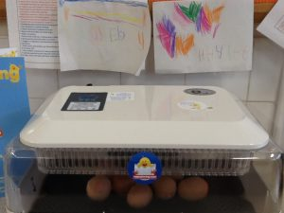
There has been some eggciting news for the children in the Reception class this week. They had a very, very special delivery of 8 eggs in an incubator.

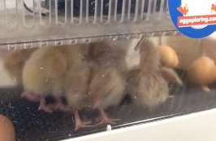
The children have watched and waited patiently for cracks to appear in the shells. By Wednesday morning their patience was rewarded when cracks slowly started to appear in the eggs, followed by 6 gorgeous little chicks! The chicks are now being looked after by the children who keep singing songs to them and drawing pictures for them to enjoy.

STUDENT SUPPORT CENTRE
On Monday, you should have received an envelope containing information about the Student Support Centre. Even if you are not interested in what the organisation offers, please just sign and tick the part which says that you are not interested in further information and return the slip to school as soon as possible. If we receive a high percentage of slips back, the company will donate resources for the children to use in school, things like dictionaries, thesaurus or maths equipment.
We need them to be returned to school by the end of next week.

FAIRTRADE FOOTBALL
Do you have a stash of old carrier bags ripped or otherwise that you no longer want/need? If so, we could really use them to make a Fairtrade Football from them. We are entering a competition with other schools to produce a football as part of Fairtrade Fortnight later this month.

YOUNG VOICES
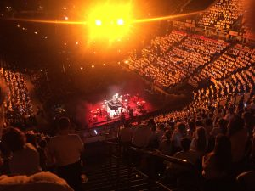
On Wednesday Years 5 and 6 eagerly boarded a coach following an early lunch to journey to the Manchester Arena to take part in one of the annual Young Voices 2017 concerts with 8,000 other children from around the area. They all sang their hearts out, it was fantastic! The children (and parents who attended) thoroughly enjoyed the evening. Thank you to our sponsors who helped us to make it an affordable event for school to take part in.

EVERY CHILD A READER
Please find attached to this Newsletter a letter from Mrs Stapleton, who has joined the Marlfields’ team as an Every Child a Reader Specialist. The letter invites you to a Reading Information evening; and also includes some tips and guidance on how to best support your child’s reading at home.

ATTENDANCE
Year 3 | 97.23%
Year 6 | 96.53%
Year 2 | 94.93%
Year 1 | 94.38%
Year 5 | 94.12%
Reception | 93.87%
Year 4 | 94.26%

Well done to Year 3
who are this
week’s winners with
97.23%

HEADTEACHER’S CHALLENGE
This week’s puzzle is ………….
“Railroad crossing, watch out of cars”.
Can you spell that without any “r’s”?

Send your answers in on Monday.

