KEY STAGE 1 CHRISTMAS PRODUCTION
Have you seen the front page and page 25 of this week’s Congleton Chronicle? There some fantastic photographs of our Key Stage 1 children which were taken at their recent Christmas production of “Christmas Counts”. The children played to a packed audience of very proud parents on Wednesday evening.

The Foundation Stage (Reception and Nursery classes) performance of “I Spy” took place this morning and was enjoyed by all; the Key Stage 2 production of Aladdin will take place tomorrow (14th December) at 6:00pm, everyone is welcome to come along to enjoy the performance.

The Clockmaker’s Christmas
School was visited recently by a theatre company to give the children a special surprise. The actors from the company performed a play called - “A Clockmaker’s Christmas”.
The play was about a Clockmaker who is disgruntled with Christmas, all he thinks about is winding clocks and keeping time. But one Christmas Eve all of that is about to change...
Ask your child about what happened next; the children enjoyed it so much that we received some lovely thank you cards and letters from them!

ECO NEWS
We recently underwent scrutiny in order to renew our Green Flag Award status. We are pleased to let you know that we have been successful with our renewal and hope to receive our new flag soon.

DATES FOR YOUR DIARY

14.12.16 | Key Stage 2 Christmas Production | 6:00pm
19.12.16 | Christingle Service  School Christmas Lunch  East Cheshire Hospice ELF RUN  All Welcome | 9:30am
Noon

2:00pm

HEADTEACHER’S CHALLENGE
Last week’s puzzle: Which vehicle is spelled the same backwards and forwards?
The answer was RACECAR
We had a number of correct entries;
well done all of you who got it right.
This week’s puzzle is ………….

I’m as light as a feather, yet the strongest man in the world can’t hold me for more than 5 minutes. What am I?
Send your answers in on a piece of paper with your name and class written on it.

ONLY 7 DAYS TO GO!
There are only 7 more days to go until we have our East Cheshire Hospice Elf Run fundraising event.
Please try hard to get as much sponsorship as you can using the special envelope which was sent home last week. If you have mis-placed yours, don’t worry we can sort you out with an alternative, simply fill in the back of this Newsletter.
Marlfields will be holding their ELF RUN on Monday 19th December from 2:00pm
On the race day children taking part will be given an elf hat to wear during the run and to take home as a memento of the event. These hats are free of charge for those children who manage to get sponsorship or if you aren’t able to get any sponsors but would like to take the hat home please bring in £2 to cover the cost of the hat. All of the funds raised will go direct to the Hospice.
There will be 1 prize per class for the child who manages to raise the most money from sponsors.

CHOIR

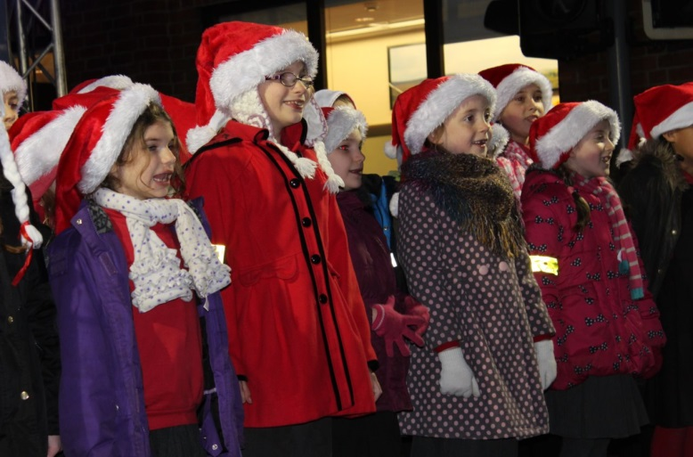

What a lovely festive photograph of a section of Marlfields Choir taken at the Christmas Lights switch on in Congleton Town Centre recently.

Our Choir are always in demand, before Christmas they have been asked to sing at the Pentecostal Church Christmas lunch, and also at Tesco.

ATTENDANCE
Year 3 | 99.54%
Year 2 | 96.52%
Year 1 | 93.97%
Year 6 | 93.83%
Reception | 93.65%
Year 5 | 91.40%
Year 4 | 90.22%

Well done to Year 3
who were last
week’s winners with 99.54%

