We’re on the final countdown to our
ELF RUN!

Not long to go now for the Elf Run in aid of the East Cheshire Hospice. We have already received quite a lot of sponsorship envelopes; however there are many, many more needed, especially if your child would like to take part.

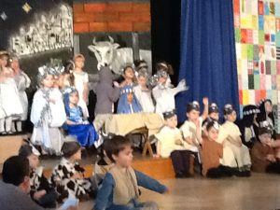
Please make sure that it’s brought into school on Monday morning in order for your child to take part in the race. Your child may dress up, as long as what they wear is not restrictive and they are able to run easily, remember we are keen on Elf ‘n’ Safety!

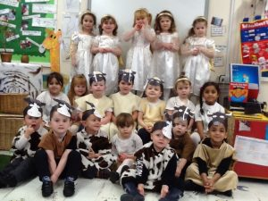
There is a small prize for the child who raises the most money in each class.

Please come along at 2:00pm to support us and cheer us on. There will be refreshments available for you to buy; all proceeds raised will go the Hospice. A representative from the Hospice will be here to start the race and answer any questions that you may have about the work that they do.

Each child taking part will be given an elf hat to wear during the run. These hats are free of charge for those children who manage to get sponsorship or if you aren’t able to get any sponsors the hats cost £2, all of the funds will go to the Hospice.

There is also the collection of £1 to persuade Mrs Isherwood to take part wearing jelly filled wellies, a sight we can’t wait to see! So send in your £1’s NOW!

We will be having a VERY busy day on the 19th; at 9:30am we will be having our Christingle Service in the school hall, please join us, everyone is most welcome.
Later on the staff and children will enjoy a lovely Christmas dinner, then, of course we will all take part in the Elf Run.

Please, please try and support the Elf Run. The work that the Hospice does is phenomenal, and is run solely on donations. If you have ever visited anyone there you would understand the need for us to raise as much money as possible to support this wonderful charity.

CHRISTMAS PRODUCTIONS
Last week we had the fabulous Key Stage 1 performance of “Christmas Counts” which we (and Congleton Chronicle) have already reported on: we didn’t think we could ever have another performance as good, but we did, we had another two performances from two different Key Stages that were every bit as good!

On Tuesday morning our Nursery and Reception children performed their play “I-Spy Christmas”, to their very proud mummies, daddies and grandparents. From the comments made by the grown-ups as they were going out, everyone thoroughly enjoyed watching the production.

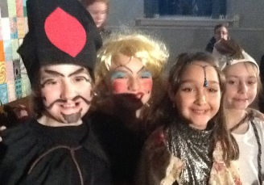
On Wednesday evening it was the turn of Key Stage 2 who performed “Aladdin” to a very full school hall.

Many thanks to all the staff and children who put in a lot of hard work, their hearts and souls into all of the productions with the hope of entertaining you all and filling you all with Christmas cheer. It worked for us!

Dates for your Diary

19.12.16 | Christingle Service  School Christmas Lunch  East Cheshire Hospice ELF RUN  All Welcome | 9:30am
Noon

2:00pm
20.12.16 | Foundation Stage visit to The Reindeer Lodge
21.12.16 | Last day in School | Finish at 3:20pm
09.01.17 | Return to school

