CHRISTINGLE
Please come along and join the school for our Christingle Service which will take place at Trinity Methodist Church on Tuesday 19th December at 9:30am. Refreshments will be available there from 9:00am.

CHRISTMAS DINNER
Don’t forget that Christmas Dinner for the children will be on Tuesday 19th December.

TRADITIONAL CAROL CONCERT
On Tuesday 19th December at 6:00pm in the school hall, the children of Key Stage 2 will be entertaining us all with a traditional Carol Service.
We hope that as many parents, grandparents and friends will come along to join with the festivities and have a sing with us.
There will be refreshments available and we will also be running a raffle. If you would like to come along please let us know how many seats you require, by completing the slip at the end of the Newsletter.

SANTA RUN
Our sponsored Santa Run will take place on the last school day, Wednesday 20th December. It would help us greatly if you could send in your Sponsor Forms and monies by Tuesday 19th December at the latest to enable us to bank the money before the holidays. We have already received 2 completed Sponsor Forms and monies; each envelope contained £30, well done to you both. The School Council have decided that the monies raised will be used to buy equipment for the playground.

EXTREME WEATHER
Please remember each day to send your child into school with a warm winter coat, hat, scarf, gloves and sensible shoes.
Boots may be worn to school, but when the children are indoors they need to change their footwear to either shoes or their P.E. pumps.
Children MUST have their P.E. kit in school every day so that if they get wet they will have something to change into.

Please ensure that you inform the Office of any changes to your telephone numbers so that if we need to text you in the event of an early closure we can ensure that you have got the message.

Should the decision to close early or to not open because of heavy snow, where possible we will text everyone, and will also place an announcement on the following local radio stations:-
Signal Radio, BBC Radio Stoke or Silk FM
96.4FM 94.6FM 106.9FM

BLUE PETER CHALLENGE
Congratulations to Vaughan in Year 5 who proudly displays his Blue Peter badge he gained. Remember to bring in you badge to show us when you have completed the challenge. The rumour is that Year 4 have taken the challenge as a whole class and badges are now arriving. Watch this space for more news.
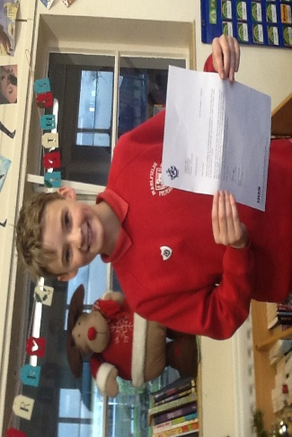

Holidays, 2017 - 2018
Last Day in School School Opens
Christmas | 20.12.17 | 08.01.18
Half Term | 16.02.18 | 26.02.18
Easter | 29.03.18 | 16.04.18
Half Term | 25.05.18 | 04.06.18
Summer Holidays | 20.07.18  23.07.18  24.07.18  INSET DAYS

