Anti-bullying Policy

- What is bullying?
1.1 Bullying is aggressive, harmful behaviour which is targeted repeatedly at one and the same individual or group of individuals. We recognise that bullying can take many forms (see Appendix).

- Aims and objectives
2.1 We aim, as a school, to produce a safe and secure environment where all can learn without anxiety.

2.2 We aim to do all we can to develop a school ethos in which bullying is regarded as unacceptable and all stakeholders take a responsibility for influencing the school ethos using effective and sustainable anti-bullying interventions.

2.3 We aim to make all those connected with the school aware of our opposition to bullying, and we make clear each person’s responsibilities with regard to the eradication of bullying in our school.

2.4 As such we have a consistent school response to any bullying incidents that may occur and run a structured and recognised anti-bullying programme called KiVA; this programme not only tackles bullying but also has numerous beneficial effects on the general well-being and motivation of all our children and stakeholders. The programme promotes positive interpersonal relationships and actively encourages consultation with stakeholders.

- What is KiVA?
3.1 KiVA is an anti-bullying programme specifically designed for the school environment and it promotes each pupil’s responsibility for the common well-being of members of the school community (see Appendix). As such the programme provides key universal actions which empower the school staff with information about bullying and how to tackle it, and simultaneously supports our commitment to anti-bullying work through structured lessons and whole school activities.

3.2 Key child-centred lessons are taught throughout the year in all classes, including a modified programme for Key Stage One and Early Years. Pupils are taught to recognise bullying and to understand their role in tackling bullying (see Appendix); the key message is to prevent bullying and to empower children to develop social skills and find solutions to experiential exercises, which will then support them should they encounter similar situations themselves. We continue the themes from KiVA such as tolerance and celebrating cultural diversity in our curriculum, learning through debates and discussions on British Values and via our PSHCE programme. The KiVA programme underlines our message that bullying in any form will not be tolerated, reported incidents will be taken seriously and thoroughly investigated using KiVA reporting formats which ensure adults listen to all parties and actively support all children.

3.3 The role of the KiVA team
The KiVA lead teacher takes overall responsibility for the implementation of the programme in the school and works as a key member of the KiVA team. The main purpose of the team is to tackle specific bullying cases together with the class teacher. Indicated actions are used when a bullying has occurred. These actions are targeted specifically to the children who are involved in bullying as perpetrators or victims. The aim is to stop bullying from occurring and the school take a Non-Confronting approach to intervention. This means that a feeling of concern is evoked in the bully, which is followed with a discussion on how the situation could be changed in the future. Marlfields closely follows the KiVA format for these discussions; records are kept and stored in a secure place. We provide a KiVA parent leaflet to ensure that parents understand the KiVA process and regularly send questionnaires to stakeholders to gather their views. The School Council team (made up of pupils elected from Years 2 to 6) are key members of the KiVA team and gain the voice of their class mates on issues surrounding bullying and school life. KiVA is a tool for empowering pupils to refrain from bullying, to make judgements as to when and how to intervene if they witness bullying, to understand their role as a bystander and be confident to report concerns or incidents.

4 The Role of the Board of Trustees
The Board of Trustees supports the Principal in all attempts to eliminate bullying from our school. This policy statement makes it very clear that the Board of Trustees does not allow bullying to take place in our school, and that any incidents of bullying that do occur are taken very seriously and dealt with appropriately.

4.1 The Board of Trustees monitors the incidents of bullying that occur, and reviews the effectiveness of the school policy regularly. The trustees require the Principal to keep accurate records of all incidents of bullying and to report to the board of trustees on request about the effectiveness of school anti-bullying strategies.

4.2 The Board of Trustees responds within ten days to any request from a parent to investigate incidents of bullying. In all cases, the Board of Trustees notifies the Principal and asks her to conduct an investigation into the case and to report back to a representative of the Board of Trustees. The board receive regular feedback at the termly meetings.

- The role of the Principal/Vice Principal

5.1 It is the responsibility of the Principal/Vice Principal to implement the school anti-bullying strategy and to ensure that all staff (both teaching and non-teaching) are aware of the school policy and know how to deal with incidents of bullying. The Principal/Vice Principal reports to the Board of Trustees about the effectiveness of the anti-bullying policy on request.

5.2 The Principal/Vice Principal ensures that all children know that bullying is wrong, and that it is unacceptable behaviour in this school. The Principal/Vice Principal draws the attention of children to this fact at suitable moments.
5.3 The Principal/Vice Principal ensures that all staff receives sufficient training to be equipped to deal with all incidents of bullying and that the school policy is in line with practices and current thinking.

5.4 The Principal/Vice Principal sets the school climate of mutual support and praise for success, so making bullying less likely.

- The role of the teacher

6.1 Teachers in our school actively foster positive self-esteem, self –respect and respect for others. All staff take all forms of bullying seriously, and intervene to prevent incidents from taking place. Teachers are trained to identify signs of bullying (see Appendix) and to respond appropriately and sensitively to the victim and perpetrator. They deliver the KiVA programme under direction of the KiVA team leader and have regular CPD to ensure they understand issues and the importance of being active listeners. They report incidents of potential bullying to the KiVA team for investigation and work with the team to resolve any issues. Clear records of all incidents that happen in their class and anywhere else in the school are recorded on KiVA documentation and kept in a KiVA file in the main office area.

6.2 If teachers witness an act of bullying, they do all they can to support the child who is being bullied. After consultation with the KiVA team and the Principal, the teacher informs the child’s parents and talks them through the KiVA intervention process. The class teacher may then do additional KiVA support lessons for the whole class to support resolution of the problem, whilst the KiVA team may be working to support the victim and the perpetrator. All reports of bullying from children or parents are dealt with in accordance with the KiVA programme and agreed procedures.

6.3 A record of any bullying incidents outside the classroom, near the school, on the children’s way home or to school is kept by the Principal. If any adult witnesses an act of bullying, they should pass on this information to the Principal.

6.4 If, as teachers, we become aware of any bullying taking place between members of a class, we deal with the issue immediately through KiVA and PSHCE lessons. This may involve dramatisation and support for all those involved in the incident as part of our approach to conflict resolution. The KiVA team spend time talking to the child who has bullied: we explain why the action of the child was wrong, and we endeavour to help the child change their behaviour in future. If a child is repeatedly involved in bullying other children, we inform the Principal, the KiVA team lead and where appropriate the special needs co-ordinator. We then invite the child’s parents into the school to discuss the situation. In more extreme cases, for example where these initial discussions have proven ineffective, the Principal may contact external support agencies.

6.5 Teachers routinely discuss any issues of bullying and when appropriate may attend training, which enables them to become equipped to deal with incidents of bullying and behaviour management. As a school we regularly timetable KiVA activities to raise the profile of anti-bullying and our school ethos.

6.6 Teachers attempt to support all children in their class and to establish a climate of trust and respect for all. By praising, rewarding and celebrating the success of all children, we aim to prevent incidents of bullying.

6.7 In school training for staff on KiVA and anti-bullying strategies as part of our Continued Professional Development is planned and linked to the school development plan. KiVA is a regular discussion during staff meetings as a means to support colleagues and disseminate good practices.

- The role of parents.

7.1 All parents are informed of the school approach to anti-bullying via our KiVA leaflet, school policy and school events. The school policy gives them signs to look for and where they can see additional advice but we ask them to work with the school first and foremost to find a solution to their child’s concern and the reported incident. We encourage any Parents who are concerned that their child might be being bullied or who suspect that their child may be the perpetrator of bullying, should contact their child’s class teacher immediately.

7.2 Parents have a responsibility to support the school’s anti-bullying policy and to actively encourage their child to be a positive member of the school. By working as a team we can prevent bullying and support all members of the school community. Marlfields encourages parents to empower their children to speak up against bullying and to reassure their child that actions will be taken to support them and resolve any issues shared so that they feel supported and safe in school. As such all parents are given the opportunity to share worries at any time as we operate a ‘open door’ policy and encourage parental involvement in all aspects of school life.

7.3 Where a case of bullying has been identified the KiVA team is the first point of call and once the issue has been acted upon by the team then the parents become involved with an incident, the parents of the perpetrator and victim will be kept informed of the outcome of the intervention work. This may take some time and involve a range of strategies to support the children and their families.

- Monitoring and review

8.1 This policy is monitored on a day-to-day basis by the Principal, who reports to governors about the effectiveness of the policy on request.

8.2 This anti-bullying policy is the governors’ responsibility and they review its effectiveness annually. They do this by accessing records and by discussion with the Principal. Key Trustees analyse information with regard to gender, age and ethnic background of all children involved in bullying incidents. Recommendations for Continuous Professional Development for staff and trustees are made and actioned as part of the review process.

9 Links to other policies
Child Protection Policy Safe Guarding
Citizenship Equal Opps
Curriculum Policies Inclusion
Behaviour & Discipline E-safety guidelines
Reviewed; September 2016

Signature on behalf of Board of Trustees ……………………………………………………………..
Next Review date; September 2017

Anti-Bullying Policy Appendix
Bullying can be:
Emotional | being unfriendly, excluding, tormenting (e.g. hiding books, threatening gestures)
Physical | pushing, kicking, biting, hitting, punching or any use of violence
Racial | racial taunts, graffiti, gestures
Sexual | unwanted physical contact or sexually abusive comments
Homophobic | because of, or focusing on the issue of sexuality
Direct or indirect Verbal | name-calling, sarcasm, spreading rumors, teasing
Cyber bullying | All areas of internet ,such as email and internet chat Twitter, Facebook misuse Mobile threats by text messaging and calls Misuse of associated technology , i.e. camera and video facilities, Ipad, games consoles,

Bullying may be related to:
- Race
- Gender
- Religion
- Culture
- SEN or disability
- Appearance or health condition
- Home circumstances (incl Young carers and poverty)
- Sexual orientation (sexism, or sexual bullying, homophobia)

Preventing Bullying

Children are involved in the prevention of bullying as and when appropriate, these may be part of a KiVA lesson or a PSHCE lesson and may include activities such as:
• writing a set of school or class rules
• writing a personal pledge or promise against bullying, signing the KiVA contract
• writing stories or poems or drawing pictures about bullying
• reading stories about bullying or making up role-plays about what to do through scenarios of bullying
• having discussions about bullying and why it matters that children who use unacceptable behaviour towards others are dealt with quickly

If a child feels that they are being bullied then there are several procedures that they are encouraged to follow: (not hierarchical)

• Tell a friend
• Tell your School Council rep or a member of the KiVA Team
• Tell a teacher or adult whom you feel you can trust
• Write your concern and post it in a Worry Box
• Tell a parent or adult at home whom you feel you can trust
• Discuss it as part of your PSHE time

Signs and Symptoms For Parents and Staff
A child may indicate by signs or behaviour that he or she is being bullied. Adults should be aware of these possible signs and that they should investigate if a child:
• is frightened of walking to or from school
• begs to be driven to school
• changes their usual routine
• is unwilling to go to school (school phobic)
• begins to truant
• becomes withdrawn anxious, or lacking in confidence
• starts stammering
• attempts or threatens suicide or runs away
• cries themselves to sleep at night or has nightmares
• feels ill in the morning
• begins to do make less effort with school work than previously
• comes home with clothes torn or books damaged
• has possessions which are damaged or " go missing"
• asks for money or starts stealing money • has dinner or other monies continually "lost"
• has unexplained cuts or bruises • comes home hungry (money / lunch has been stolen)
• becomes aggressive, disruptive or unreasonable
• is bullying other children or siblings
• stops eating
• is frightened to say what's wrong
• gives improbable excuses for any of the above
• is afraid to use the internet or mobile phone
• is nervous and jumpy when a cyber message is received
• lack of eye contact
• becoming short tempered
• change in attitude to people at home.

These signs and behaviours could indicate other social, emotional and/or mental health problems, but bullying should be considered a possibility and should be investigated.

Advice to Parents
As the parent of a child whom you suspect is being bullied-
1. Report bullying incidents to the class teacher or KiVA Anti-Bullying Co-ordinator
2. In cases of serious bullying, the incidents will be recorded by staff and the Principal notified.
3. In serious cases parents should be informed and will be asked to come in to a meeting to discuss the problem
4. If necessary and appropriate, police will be consulted
5. The bullying behaviour or threats of bullying must be investigated and the bullying stopped quickly
6. An attempt will be made to help the child using unacceptable behaviour towards others, to change their behaviour.
Do Not:
1. Attempt to sort the problem out yourself by speaking to the child whom you think may be behaving inappropriately towards your child or by speaking to their parents.
2. Encourage your child to be ‘a bully’ back.
HELP ORGANISATIONS:
Advisory Centre for Education (ACE) 020 7354 8321 Children's Legal Centre 0845 345 4345
KIDSCAPE Parents Helpline (Mon-Fri, 10-4) 0845 1 205 204
Parentline Plus 0808 800 2222Bullying Online www.bullying.co.uk
Visit the Kidscape website www.kidscape.org.uk for further support, links and advice.
Parent leaflets are available on KiVA website for further information.
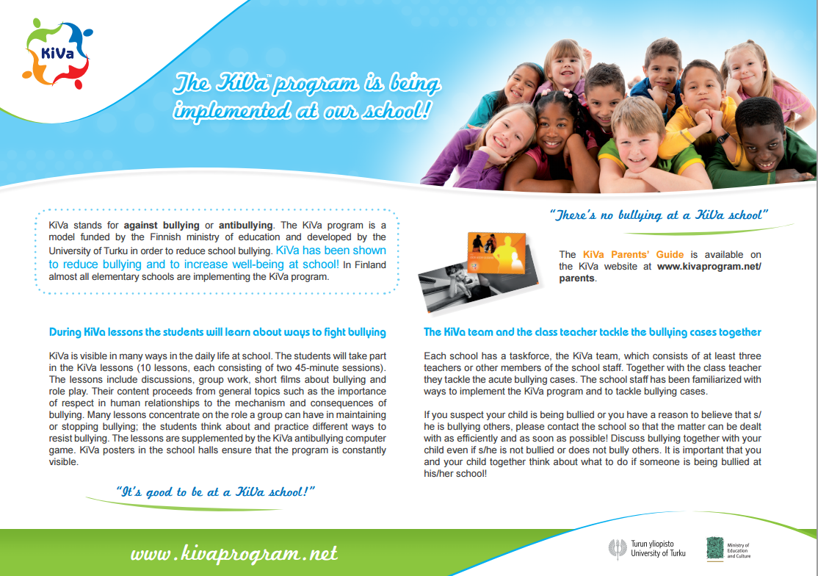

We use the Kiva Website to support our own School Parental Leaflet for KiVA

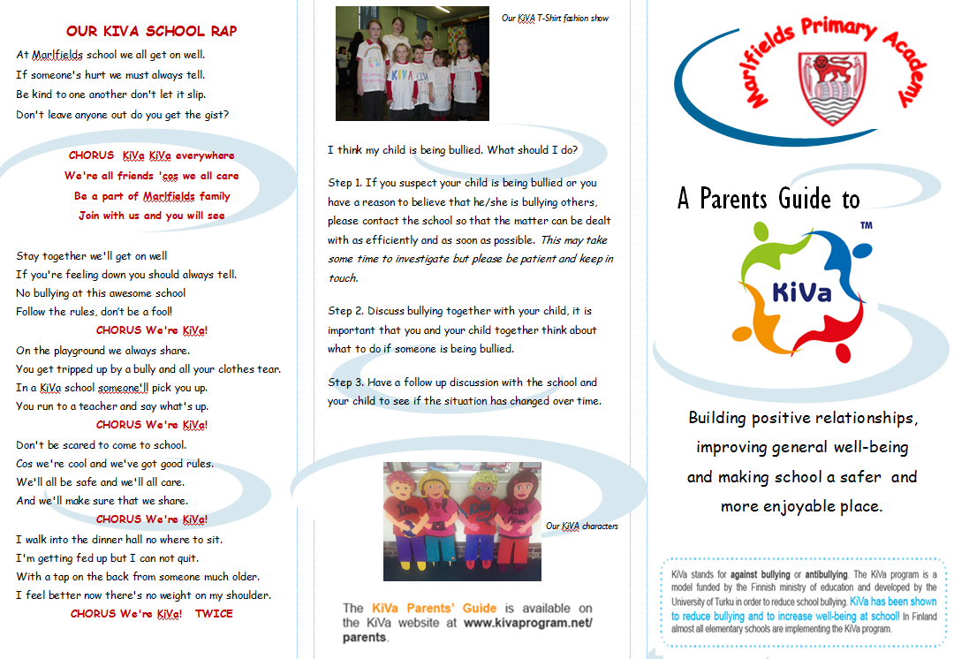

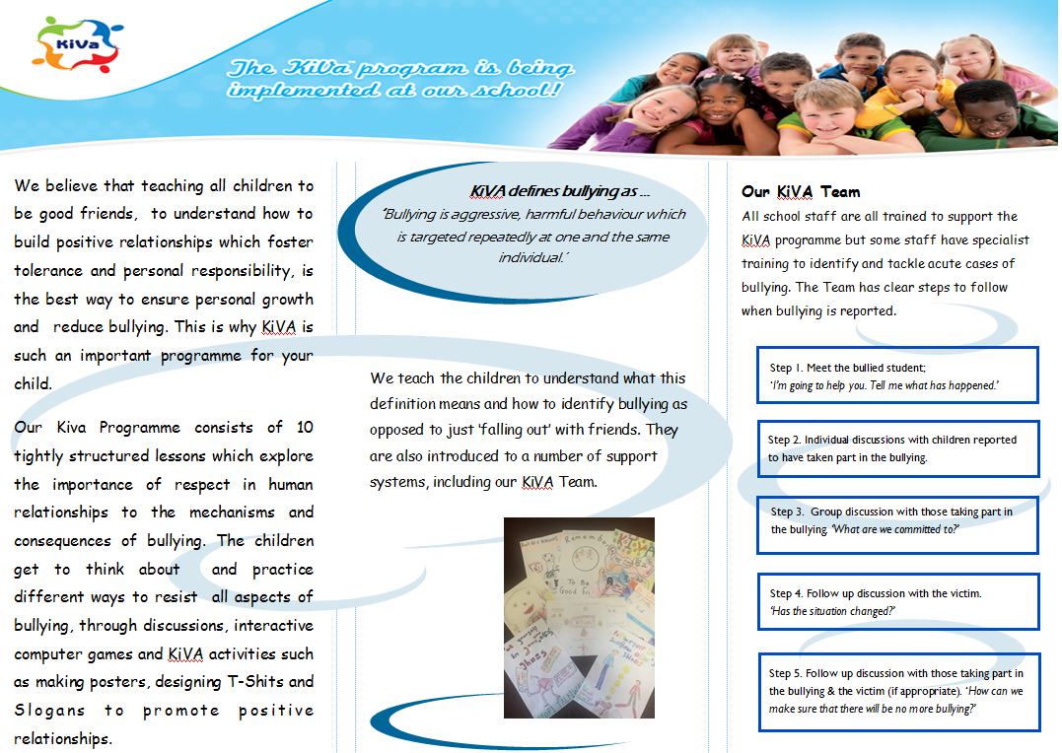

What can you do if you see someone else being bullied? (The role of the bystander)
Ignoring bullying is cowardly and unfair to the victim. Staying silent means the bully has won and gives them more power. There are ways you can help without putting yourself in danger. The children discuss this question in class and strategies to show they are against bullying:
- Don’t smile or laugh at the situation.
- Don’t rush over and take the bully on yourself.
- Don’t be made to join in.
- If safe to do so, encourage the bully to stop bullying.
- If you can, let the bully know you do not like his or her behaviour.
- Shout for help.
- Let the victim(s) know that you are going to get help.
- Tell a member of staff as soon as you can.
- Try and befriend the person being bullied.
- Encourage the person to talk to someone and get help.
- Ask someone you trust about what to do.
- If you don’t feel you can talk to someone about it, write it down and post it in the ‘Worry’ box.
- Call a helpline for some advice.

KiVa Curriculum and cross references to PSHE at KS2
 |  |  |  |  |  |  |  |  |  |  |  |  |  |  |  |  |  |  |  |  |  |  |  |  |  |  | PSHE curriculum KS2
Lesson 1 |  |  |  |  |  |  |  |  |  |  |  |  |  |  |  |  |  |  |  |  |  |  |  |  |  |  | Developing confidence and responsibility and making the most of thier abilities
Know that KiVa stands for a positive school environment |  |  |  |  |  |  |  |  |  |  |  |  |  |  |  |  |  |  |  |  |  |  |  |  |  |  | 1a. To talk and write about thier opinions and explain thier views, on issues that affect themselves and society
understand that everyone has the right to a safe learning environment |  |  |  |  |  |  |  |  |  |  |  |  |  |  |  |  |  |  |  |  |  |  |  |  |  |  | 1c. To face new challenges positively by collecting information, ooking for help, making responsible choices and taking action
understand that being alone is different from being together and that both of them are important
understand the importance of respect in human relationships and know what is respectful and disrespectful behaviour |  |  |  |  |  |  |  |  |  |  |  |  |  |  |  |  |  |  |  |  |  |  |  |  |  |  | Preparing to play an active role as citizens
understand what interpersonal communication is and what problems it might present |  |  |  |  |  |  |  |  |  |  |  |  |  |  |  |  |  |  |  |  |  |  |  |  |  |  | 2a. To research, discuss and debate topical issues, problems and events
 |  |  |  |  |  |  |  |  |  |  |  |  |  |  |  |  |  |  |  |  |  |  |  |  |  |  | 2c. To realise the consequences of anti-social and aggressive behaviours, such as bullying, racism, on idividuals and communities
Lesson 2 |  |  |  |  |  |  |  |  |  |  |  |  |  |  |  |  |  |  |  |  |  |  |  |  |  |  | 2e. To reflect on spiritual, moral, social and cultural issues, using imagination to understand other people's experiences
know what a group is |  |  |  |  |  |  |  |  |  |  |  |  |  |  |  |  |  |  |  |  |  |  |  |  |  |  | 2f. To resolve differences by looking at alternatives, making decisions and explaining choices
have thought of examples of a friendly group
understand characteristics of communication in a group |  |  |  |  |  |  |  |  |  |  |  |  |  |  |  |  |  |  |  |  |  |  |  |  |  |  | Developing a healthy, safer lifestyle
understand that sometimes in a group you end up behaving in a manner you don't really want to |  |  |  |  |  |  |  |  |  |  |  |  |  |  |  |  |  |  |  |  |  |  |  |  |  |  | 3a. What makes a healthy lifestyle.........what affects mental health.....
understand that in a group people have different kinds of roles and that the group itself contributes to defining  those roles |  |  |  |  |  |  |  |  |  |  |  |  |  |  |  |  |  |  |  |  |  |  |  |  |  |  | 3e. To recognise the different risks in different situations and then decide how to behave responsibly........
know how to join a group and how to help others to be included in the group |  |  |  |  |  |  |  |  |  |  |  |  |  |  |  |  |  |  |  |  |  |  |  |  |  |  | 3f. That pressure to behave in an unacceptable or risky way can come from a variety of sources, including people they know and how
have thought about what kind of a group his/her own class is |  |  |  |  |  |  |  |  |  |  |  |  |  |  |  |  |  |  |  |  |  |  |  |  |  |  | to ask for help and use basic techniques for resisting pressure to do wrong
 |  |  |  |  |  |  |  |  |  |  |  |  |  |  |  |  |  |  |  |  |  |  |  |  |  |  | 3g. School rules.............where to get help
Lesson 3
know what bullying is and able to recognise bullying situations |  |  |  |  |  |  |  |  |  |  |  |  |  |  |  |  |  |  |  |  |  |  |  |  |  |  | Developing good relationships and respecting the differences between people
also know what is not bullying (a conflict/fight) |  |  |  |  |  |  |  |  |  |  |  |  |  |  |  |  |  |  |  |  |  |  |  |  |  |  | 4a. That their actions can affect themselves and others, to care about other people's feelings and to try to see things from thier points of view
know about different forms of bullying |  |  |  |  |  |  |  |  |  |  |  |  |  |  |  |  |  |  |  |  |  |  |  |  |  |  | 4c. To be aware of different types of relationship...................and to develop skills to be effective in relationships
know how common a problem bullying is |  |  |  |  |  |  |  |  |  |  |  |  |  |  |  |  |  |  |  |  |  |  |  |  |  |  | 4d. To realise the nature and consequences of racism, teasing, bullying and aggressive behaviours and how to respond to them and ask for help
understand that even though bullying is common it is not acceptable |  |  |  |  |  |  |  |  |  |  |  |  |  |  |  |  |  |  |  |  |  |  |  |  |  |  | 4g. Where individuals, families and groups can get help and support
know who to tell about bullying and how it is tackled at school
 |  |  |  |  |  |  |  |  |  |  |  |  |  |  |  |  |  |  |  |  |  |  |  |  |  |  | Breadth of opportunities
Lesson 4 |  |  |  |  |  |  |  |  |  |  |  |  |  |  |  |  |  |  |  |  |  |  |  |  |  |  | 5a. Take responsibility (eg. For the needs of others, such as including others in a group; creating a friendly class environment;
understand the concept of hidden bullying |  |  |  |  |  |  |  |  |  |  |  |  |  |  |  |  |  |  |  |  |  |  |  |  |  |  | to report any incidents of bullying)
understand what mixed messages are |  |  |  |  |  |  |  |  |  |  |  |  |  |  |  |  |  |  |  |  |  |  |  |  |  |  | 5b. Feel positive about themselves (eg. Resist negative peer pressure; record and recognise thier learning achievements)
know what cyber-bullying is |  |  |  |  |  |  |  |  |  |  |  |  |  |  |  |  |  |  |  |  |  |  |  |  |  |  | 5c. Participate (eg. Development of class and school anti-bullying rules)
understand that hidden bullying is harmful and forbidden |  |  |  |  |  |  |  |  |  |  |  |  |  |  |  |  |  |  |  |  |  |  |  |  |  |  | 5d. Make real choices and decisions (eg. How they behave in a group situation; how to support a victim of bullying)
know ways to protect him/herself from online bullying |  |  |  |  |  |  |  |  |  |  |  |  |  |  |  |  |  |  |  |  |  |  |  |  |  |  | 5f. Develop relationships through work and play (eg. Taking part in group activities in the class; empathsing with peers in different situations)
 |  |  |  |  |  |  |  |  |  |  |  |  |  |  |  |  |  |  |  |  |  |  |  |  |  |  | 5g. Consider social and moral dilemmas that they come across in life (eg. Dealing with bullying)
Lesson 5 |  |  |  |  |  |  |  |  |  |  |  |  |  |  |  |  |  |  |  |  |  |  |  |  |  |  | 5h. Find information and advice (eg. Using the KiVa games)
understand what being bullied may feel like
know the most common consequences of being bullied
understand that being bullied might affect your life after many years
have thought about the well-being of his/her class as a group and the possible changes that have taken place
Lesson 6
Have thought about his/her own attitudes towards bullying
have noticed that most of the children in the class have an attitude against bullying
have understood that you don't always act according to your actual attitude (peer pressure)
know the roles in bullying situations
have thought about his/her own behaviour in bullying situations
Lesson 7
have identified ways to support the victim
have thought about why it might be hard to take the victims side
understand that even small gestures/actions can make the victim feel better
have tried out different ways of behaving in a bullying situation
Lesson 8
know what s/he could do if s/he gets bullied
know what not to do is s/he gets bullied
know what assertiveness is
know what happens in his/her school if a teacher finds out that someone is being bullied
know that it may feel difficult to tell anyone about bullying (shame)
Lesson 9
have revised the anti-bullying rules of the class created during the school year
have thought about what the rules mean in his/her class
have thought about what the class could do in the future so that there would be no more bullying
know the consequences for breaking the rules
Lesson 10
have thought about how s/he feels the situation in the class has changed
have seen how others experience it
have thought of how s/he has contributed to the change / the fact that the situation has remained the same

PSHE curriculum KS2
Developing confidence and responsibility and making the most of their abilities
1a. To talk and write about their opinions and explain their views, on issues that affect themselves and society
1c. To face new challenges positively by collecting information, looking for help, making responsible choices and
taking action
Preparing to play an active role as citizens
2a. To research, discuss and debate topical issues, problems and events
2c. To realise the consequences of anti-social and aggressive behaviours, such as bullying, racism, on individuals
and communities
2e. To reflect on spiritual, moral, social and cultural issues, using imagination to understand other people's
experiences
2f. To resolve differences by looking at alternatives, making decisions and explaining choices
Developing a healthy, safer lifestyle
3a. What makes a healthy lifestyle.........what affects mental health.....
3e. To recognise the different risks in different situations and then decide how to behave responsibly........
3f. That pressure to behave in an unacceptable or risky way can come from a variety of sources, including people
they know and how
to ask for help and use basic techniques for resisting pressure to do wrong
3g. School rules.............where to get help
Developing good relationships and respecting the differences between people
4a. That their actions can affect themselves and others, to care about other people's feelings and to try to see
things from their points of view
4c. To be aware of different types of relationship...................and to develop skills to be effective in relationships
4d. To realise the nature and consequences of racism, teasing, bullying and aggressive behaviours and how to
respond to them and ask for help
4g. Where individuals, families and groups can get help and support
Breadth of opportunities
5a. Take responsibility (eg. For the needs of others, such as including others in a group; creating a friendly class
environment;
to report any incidents of bullying)
5b. Feel positive about themselves (eg. Resist negative peer pressure; record and recognise their learning achievements)
5c. Participate (eg. Development of class and school anti-bullying rules)
5d. Make real choices and decisions (eg. How they behave in a group situation; how to support a victim of bullying)
5f. Develop relationships through work and play (eg. Taking part in group activities in the class; empathising with
peers in different situations)
5g. Consider social and moral dilemmas that they come across in life (eg. Dealing with bullying)
5h. Find information and advice (eg. Using the KiVa games)

